**Client: Scalawags Veterinary Clinic**



**Kevin Yang**

**John Beguhl**

**Jisung Woo**

**Table of Contents**

***Page 1:*** Title Page

***Page 2:*** Table of Contents

***Page 3:*** Executive Summary

***Page 4 - 6:*** Team Introduction

***Page 7 - 8:*** Team Sparky’s Finest #16 Charter/Code of Ethics

***Page 9:*** Team Roles and Planned Schedule

***Page 10:*** Client Introduction and Requirements

***Page 11:*** Initial ERD

***Page 12:*** Revised ERD

***Page 13 - 16:*** Data Dictionary

***Page 17:*** DataBase Schema

***Page 18-29:*** SQL Server Data Tables

**Page *30-45:*** Database Queries

**Page *46-52:*** Data Visualization

**Page *53:*** Team Challenges

**Page *54:*** Lessons Learned

**Page *55-90:*** Appendix A

**Page *91-106:*** Appendix B

**Page *107-128:*** Appendix C

**Page *129-140:*** Appendix D

**Executive Summary**

This document will take you through the course of this semester and show you how we have progressed and what we have done for our client, Scalawags Veterinary Clinic.

At the beginning of this document you will be introduced to our team and then our client. Next, you will find the beginnings of our database ERD and the evolution of it as the semester progressed. We will then provide our database scripts and tables for different types of queries we’ve executed for the clients. Then we will show the visualization of the three data that our client will likely want. We then discussed the different difficulties that we encountered while working on this project and the lessons that we learned from them.

Building a database for a business can be a lengthy process. We followed step by step according to DDLC (database development life cycle). Starting from database planning, system definition, requirements collection and analysis, database design, implementation, data conversion and loading, and finally testing and maintenance.

Overall, we learned a lot from working with this client. It was rough at first due to some issues within our team but after ironing those out it was enjoyable to work with Scalawag. We are thrilled that we learned how converting a business’ database looks like.

**Team Introductions**

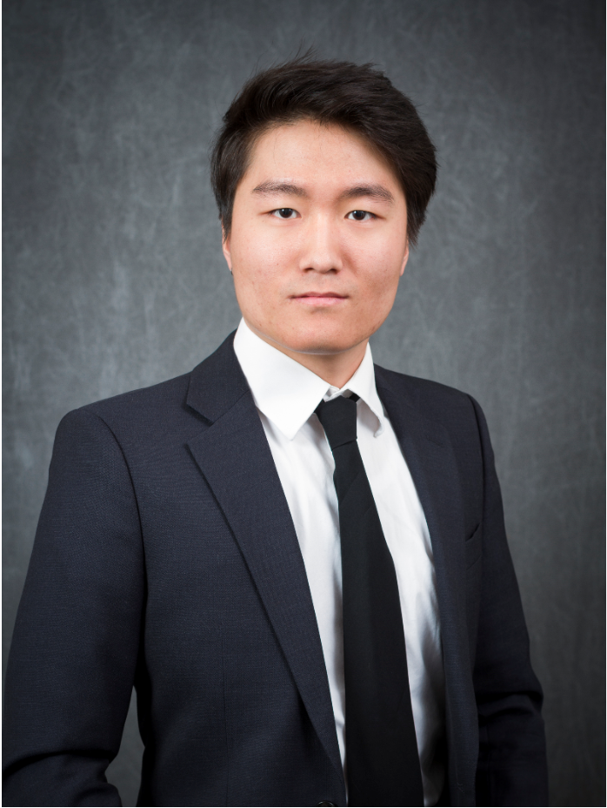

***Introductions: Jisung Woo***

Jisung Woo is a well-spoken man, he is good at badminton and fancy watching soccer. Jisung is a natural-friendly person because he loves peaceful rural areas. According to Jisung’s answer, I have a thought that Jisung is a loyal and responsible person. He doesn’t like negative people, friends and family make him happy and his childhood dream is to be a teacher. Also, he would like to spend more time with friends and family when he has leisure time. In addition, he is a very patriotic person and so proud of his country. He loves singing Korean ballad songs and eating Korean BBQ. Last Thursday, Jisung and I were a temporary team. I noticed his email’s background is Korean national flag. Jisung is a respectable and honest person who loves his country with honor.

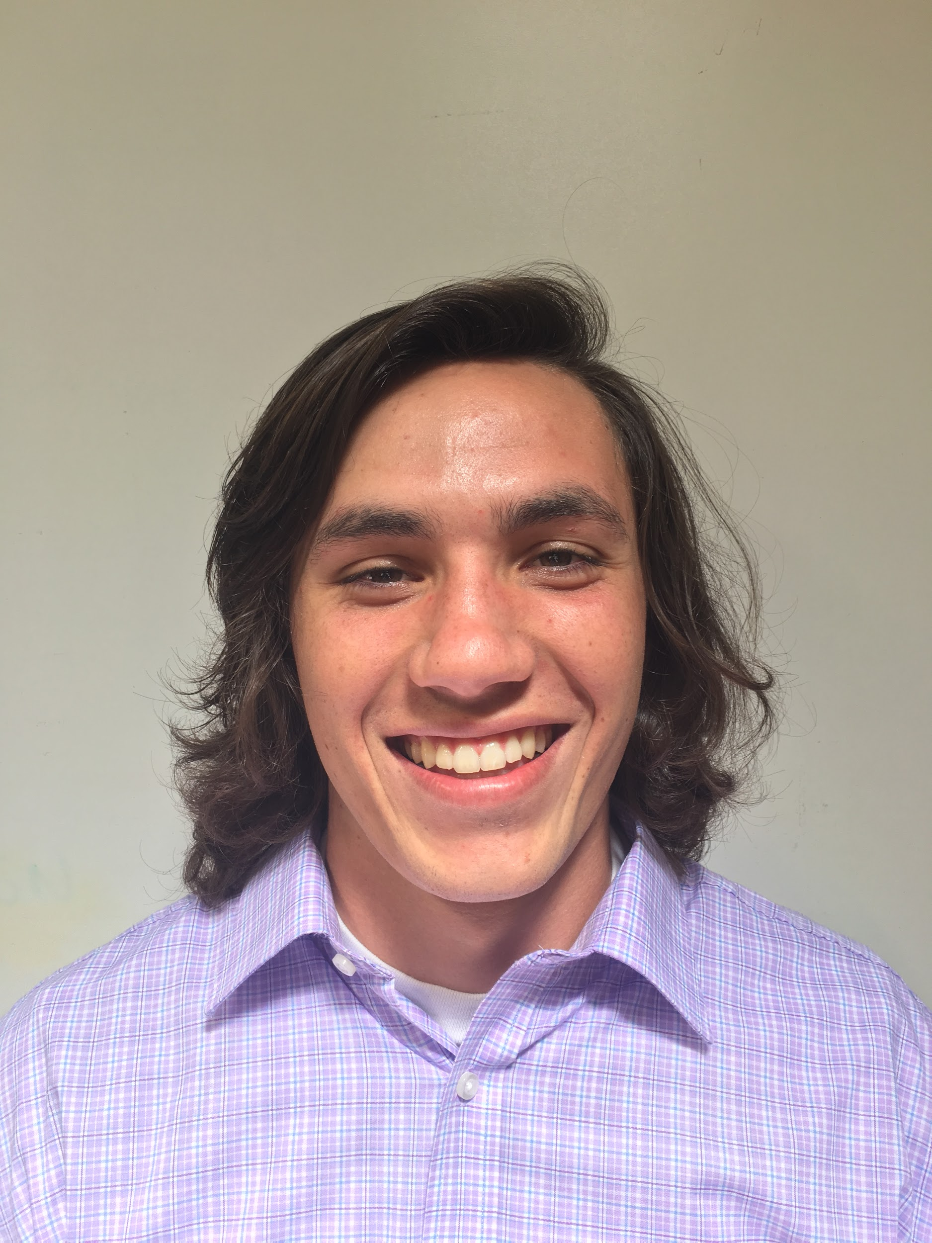

***Introductions: John Beguhl***

John has several nicknames but most people call him Jip. Jip enjoys hiking, golfing and camping. He is an adventurous yet sporadic individual. John is so adventurous that he attempted a 20ft gainer. John is also a clean and organized person. He even works out a few times a week and plays frisbee to stay in shape. He undoubtedly enjoyed seeing Jon Bellion live more than any other performance he’s watched. Finally, if John could share coffee with any celebrity, it would be Shia Lebeouf. John is a hard working and dedicated team member.

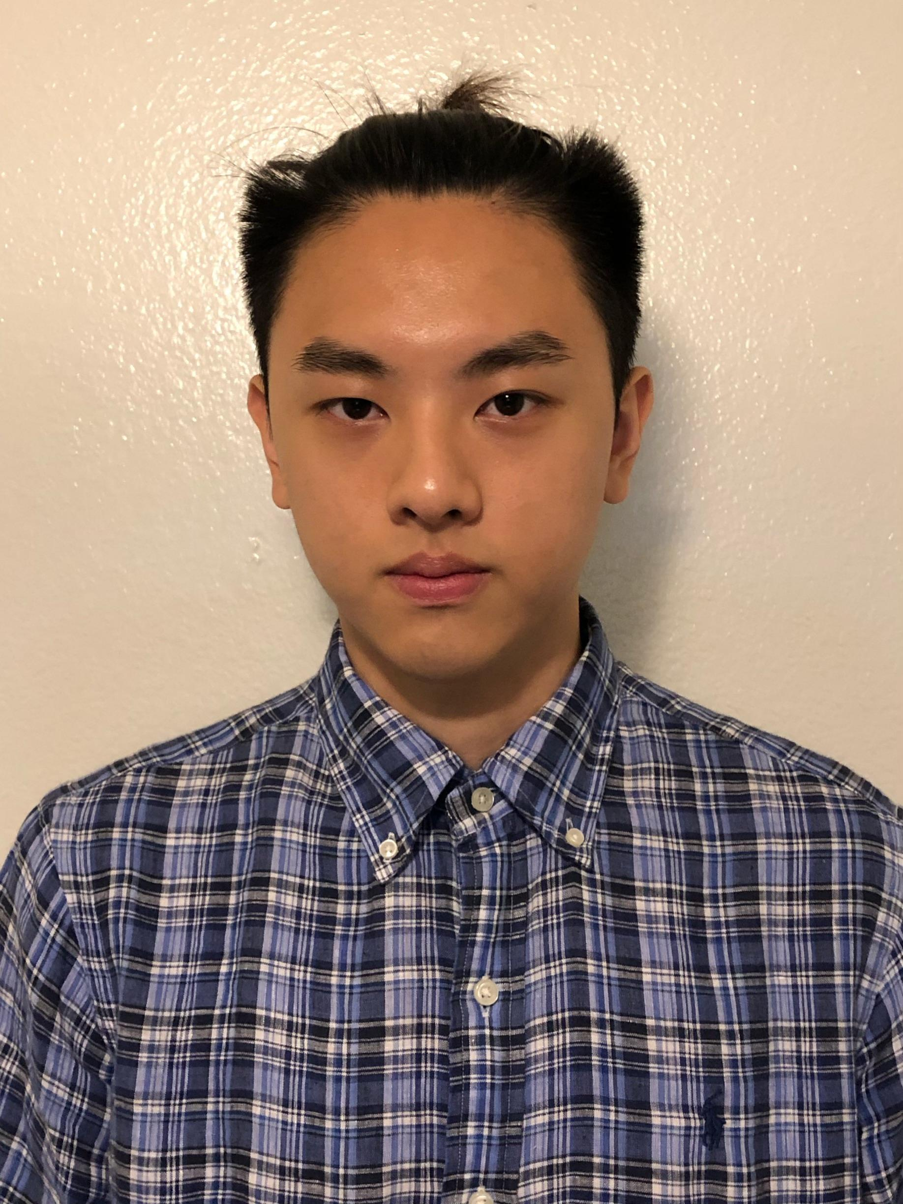

***Introductions: Kevin Yang***

Although I am a laid-back person, I still take important tasks seriously. My biggest fear is regret, so I would make sure I do everything I can to prevent that. My life goal is to work until I make enough money for early retirement. I enjoy video games, anime, and movies in my free time. Like everyone else on this planet I also enjoy good food. I am open minded and would often embrace new things in life. People who knew me would describe me as a resourceful person because I can always find a way to resolve their problems. My mother is an artist, so I was taught to be artistic and creative with what I do in life. I am decent at making art and designs.

**Team Sparky’s Finest #16 Charter/Code of Ethics**

We, the Sparky’s Finest team, having signed the attached Team Membership Agreement, have developed the following code of ethics to manage our project team activities. This Team Charter/Code specifies the minimum expectations of appropriate behavior for each team member, and will be used to evaluate any potential problems.

If, in the future, we determine that the rules specified in this document should be modified or supplemented, we may produce a revised version. At that time, the revised version will become effective, and the older version will be null.

**Code of Conduct:**  As a project team, we will:

* Make this project a priority
* Put the teams goals first
* Give our best effort towards this project

**Participation:** We will:

* Each do our fair share of work
* Be on time to class and team meetings
* Turn in work when communicated
* Be an active participant in team meetings

**Communication:** We will:

* Communicate efficiently and kindly
* Respond to group chat when necessary
* Inform team members if they will be absent for team meetings
* Let other team members know if we need help

**Problem Solving:** We will:

* Talks about any roadblocks as a team
* Find the best solution for any problems that we might face
* Work out problems as a team

**Meeting Guidelines:** We will:

* Be on time to meetings
* Come prepared to share ideas
* Be attentive during meetings
* Not use our phones unless needed

We, the undersigned, accept the conditions of team membership for CIS 365. The specific conditions of team membership are recorded in the Team Charter which we have developed and attached.

The Charter reflects the minimum level of performance that is expected of any group member. If a group member fails to meet this minimum level, they may be subject to the following consequences:

1. Send an apology letter to each of the team members with reason for letter
2. Go into an elevator and say “ Peter Piper Pizza”
3. Post a selfie with “I am so COOL!” on social media, and get 15 LIKE.
4. Buy a cup of coffee to everyone who participated in the meeting
5. Singing a song in front of the entire class

**Project Team Name:** Sparky’s Finest

|  |  |  |
| --- | --- | --- |
| **Typed Name:** | **Signature:** | **Date:** |
| John Beguhl | John Beguhl | 9/12/2019 |
| Jisung Woo | Jisung Woo | 9/12/2019 |
| Kevin Yang | Kevin Yang | 9/14/2019 |

**Team Roles and Planned Schedule**

**Facilitator:** Jisung Woo

**Follow Thru:** John Beguhl

**Implementor:** Kevin Yang

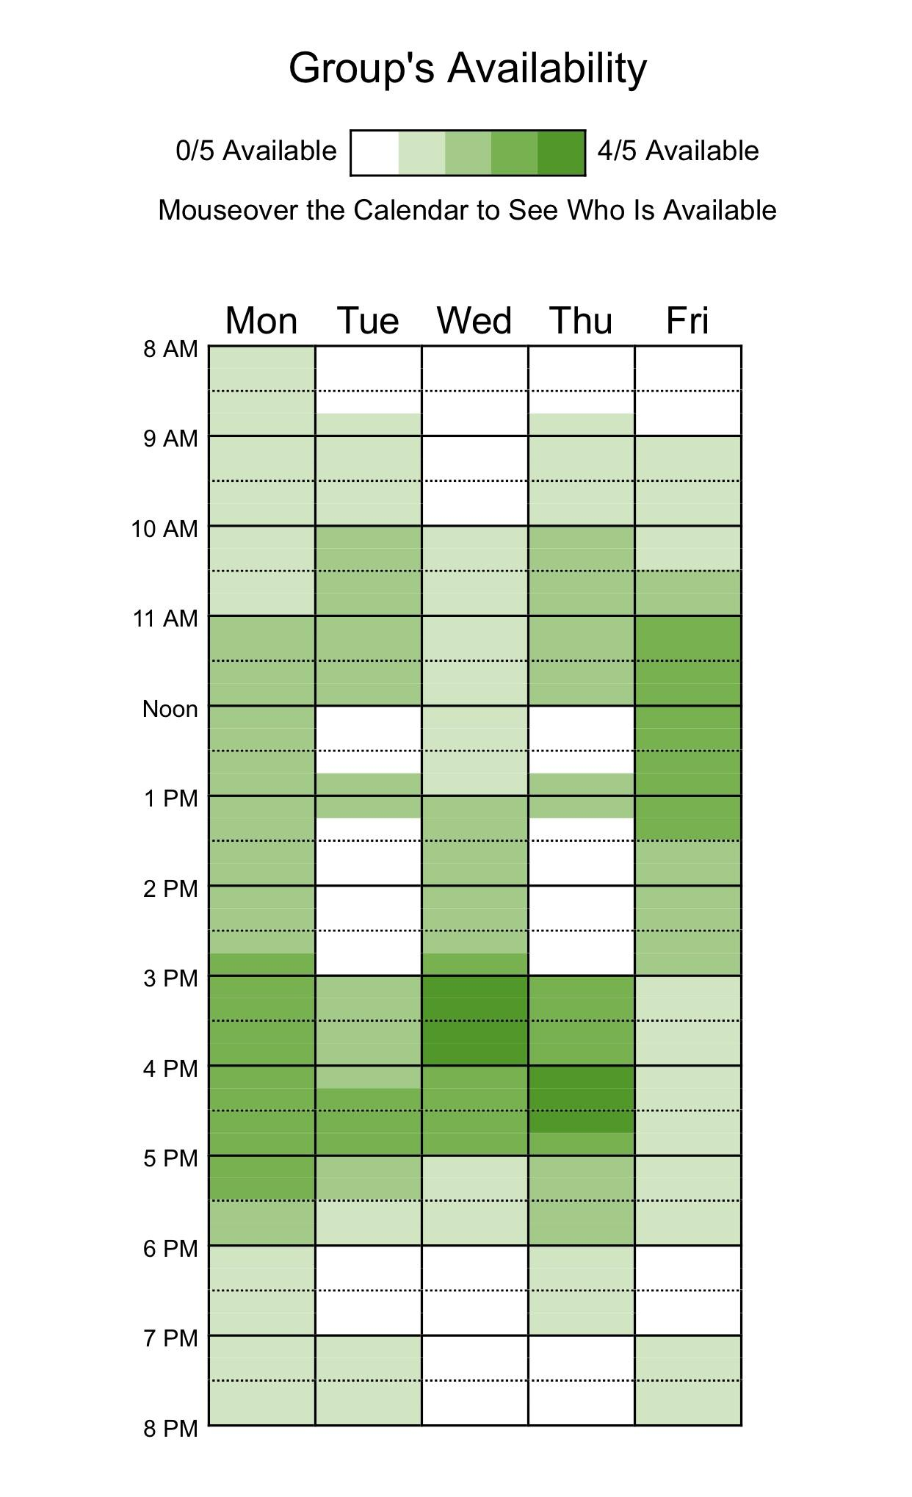

**Client Introduction and Requirements**

Our client is Scalawags Veterinary Clinic. The clinic is owned by Dr. Randi Stedman and it is located in Henderson, Nevada. Her business has slowly been growing over the past six years. Currently, Scalawags is still using the file system. This has been shown to be very inefficient. Often time files will get misplaced and cannot be found for hours. This usually occurs during shift changes. They are also experiencing inefficiency when training new employees because of all codes for the treatments.

Scalawags has hired us to do two main things: 1) to get her record keeping up to date and 2) to offer more services to her clients. They are on a tight budget but understand that there will be start up costs. Dr. Randi is willing to incur them if it allows her more independence in the running of her business.

**Initial ERD**

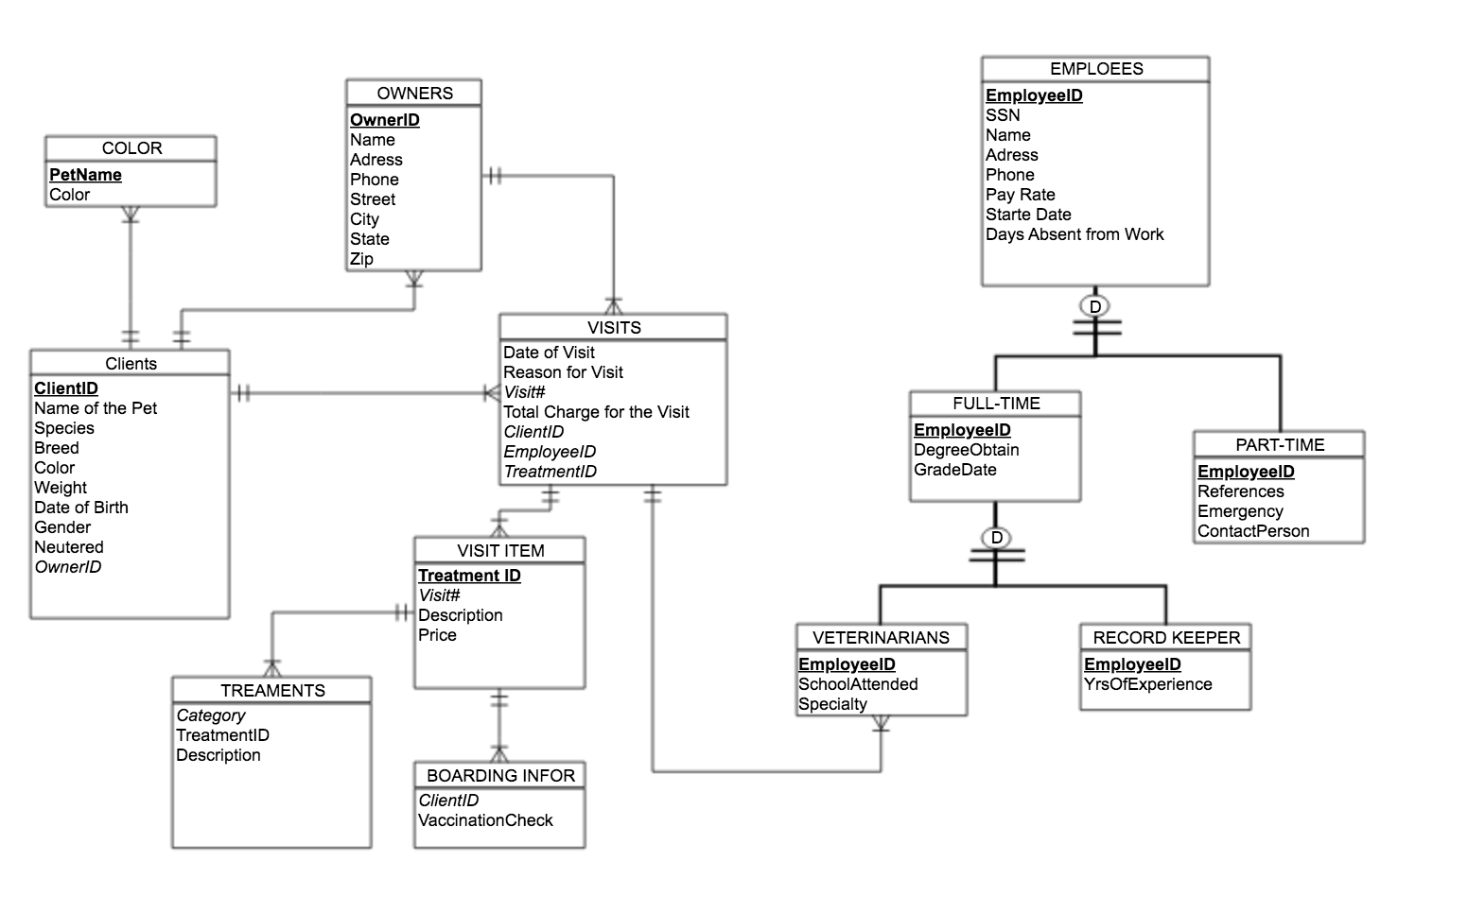

**Revised ERD**

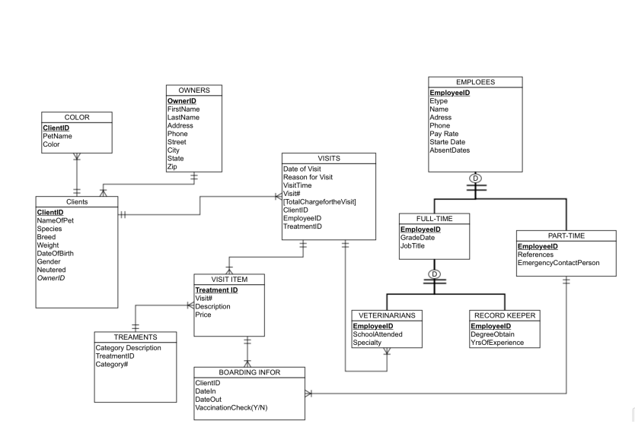

**Data Dictionary**

|  |  |  |
| --- | --- | --- |
| ***Entity*** | ***Attributes*** | ***Definition*** |
| VISITS | Date of Visit | Each 2-digit number represent day, month, and year. The data should be formed as Month/Day/Year, eg. 01/01/2019. |
| VISITS | Reason for Visit | Reason for visit max length 50 chars (eg. for diagnoses, for procedures, for medical goods and services) |
| Visits | Visit Time | Time of check in |
| VISITS | *Visit#* | 3 character code and 4 digit number uniquely identifying the visits, assigned by Scalawags Veterinary Clinic |
| VISITS | Total Charge for the Visits | The total cost of visit, New registrants start at $0.00; 2 decimal places |
| VISITS | *ClientID* | 4-digit number uniquely identifying the client, assigned by Scalawags Veterinary Clinic |
| VISITS | *EmployeeID* | 2-digit number uniquely identifying the employee, assigned by Scalawags Veterinary Clinic |
| VISITS | *TreatmentID* | 5-digit number uniquely identifying the treatment, assigned by Scalawags Veterinary Clinic |
| VISIT ITEM | ***TreatmentID*** | 5-digit number uniquely identifying the treatment, assigned by Scalawags Veterinary Clinic |
| VISIT ITEM | *Visit#* | 3 character code and 4 digit number uniquely identifying the visits, assigned by Scalawags Veterinary Clinic |
| VISIT ITEM | Description | The detail types of treatment, 3-digit number and character data, 3-digit number starts at 1.01 and ends at 5.01,character data is max-length 30 |
| VISIT ITEM | Price | The cost of treatment, New registrants start at $0.00; 2 decimal places |
| TREATMENTS | *Category* | The types of treatment, character data, max-length 20 |
| TREATMENTS | TreatmentID | 5-digit number uniquely identifying the treatment, assigned by Scalawags Veterinary Clinic |
| TREATMENTS | Description | The detail types of treatment, 3-digit number and character data, 3-digit number starts at 1.01 and ends 5.01,character data is max-length 30 |
| BOARDING INFO | *ClientID* | 4-digit number uniquely identifying the client, assigned by Scalawags Veterinary Clinic |
| BOARDING INFO | *Date in* | Date of CheckIn MM/DD/YYYY |
| BOARDING INFO | *Date Out* | Date of Check out MM/DD/YYYY |
| BOARDING INFO | VaccinationCheck | Vaccinations are for dogs and cats, character data, max-length 30 |
| CLIENT | **ClientID** | 4-digit number uniquely identifying the client, assigned by Scalawags Veterinary Clinic |
| CLIENT | Name of the Pet | (required), character data, max-length 30 |
| CLIENT | Species | The species of pets, character data, max-length 10 |
| CLIENT | Breed | The breed of pets, character data, max-length 20 |
| CLIENT | Weight | The weight of the pet in pounds |
| CLIENT | Date of Birth | Date of birth of the pet in MM/DD/YYYY format. If exact date is not know then the birth month and year will suffice. |
| CLIENT | Gender | M/F |
| CLIENT | Neutered/Spayed | Y/N |
| CLIENT | *OwnerID* | 4-digit number uniquely identifying the owner, assigned by Scalawags Veterinary Clinic |
| COLOR | **ClientID** | (required), character data, max-length 30 |
| COLOR | PetName | Name of the Pet |
| COLOR | Color | The color(s) of the pet |
| EMPLOYEES | **EmployeeID** | 2-digit number uniquely identifying the employee, assigned by Scalawags Veterinary Clinic |
| EMPLOYEES | FirstName | First Name of the employee |
| EMPLOYEES | LastName | Last Name of the employee |
| EMPLOYEES | Address | Address of the employee |
| EMPLOYEES | Phone | Phone number of the employee, max length 10 |
| EMPLOYEES | PayRate | Pay rate of the employee given by Scalawags Veterinary Clinic in $XX.XX format |
| EMPLOYEES | StartDate | Official start date of the employee in MM/DD/YYYY format |
| EMPLOYEES | Days Absent from Work | The amount of days the employee has been absent from work |
| EMPLOYEES | EType | Part-time or Full-Time |
| FULL-TIME | **EmployeeID** | 2-digit number uniquely identifying the employee, assigned by Scalawags Veterinary Clinic |
| FULL-TIME | GradeDate | Grad Date in MM/DD/YYYY format. |
| FULL-TIME | Job Title | Title of Job |
| PART-TIME | **EmployeeID** | 2-digit number uniquely identifying the employee, assigned by Scalawags Veterinary Clinic |
| PART-TIME | References | References in first name initial and last name format. (eg. J.Smith) |
| PART-TIME | ContactPerson | Contact Person in first name initial and last name format. (eg. J.Smith) |
| VETERINARIANS | **EmployeeID** | 2-digit number uniquely identifying the employee, assigned by Scalawags Veterinary Clinic |
| VETERINARIANS | SchoolAttended | School Attended in colloquial names for universities and colleges format(eg. ASU Arizona State University) |
| VETERINARIANS | Speciality | 22 recognized veterinary specialties, max length 35 chars (eg. Toxicology) |
| RECORD-KEEPER | **EmployeeID** | 2-digit number uniquely identifying the employee, assigned by Scalawags Veterinary Clinic |
| RECORD-KEEPER | YrsOfExperience | 2-digit number, (0-99) |
| RECORD-KEEPER | DegreeObtain | BA/BS, MA/MS, PHD (Bachelor of Arts/ Bachelor of Science, Master of Arts/ Master of Science, Doctoral) |
| OWNERS | **OwnerID** | **-digit number uniquely identifying the owner, assigned by Scalawags Veterinary Clinic |
| OWNERS | FirstName | First Name (Max length 35 chars), |
| OWNERS | LastName | Last Name (Max length 35 chars) |
| OWNERS | Address | Address format (Street, City, State, Zip) |
| OWNERS | Phone | Phone number of the owner, max length 10 (xxx-xxx-xxxx) |
| OWNERS | Street | Street name max length 35 chars |
| OWNERS | City | Max-length 28 chars |
| OWNERS | State | State in U.S. State Postal Abbreviations format. (eg. AZ Arizona) |
| OWNERS | Zip | Zip is a 5-digit code (max length 9) |

**DataBase Schema**

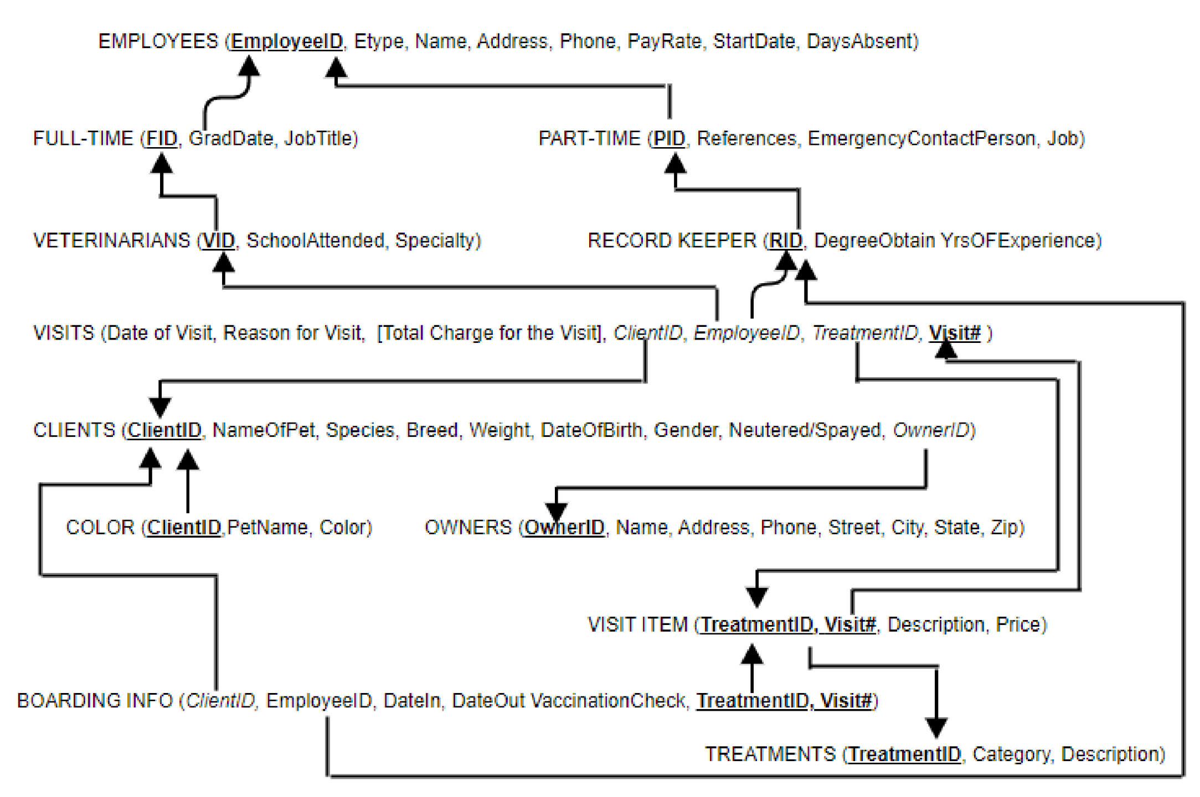

**SQL Server Data Tables**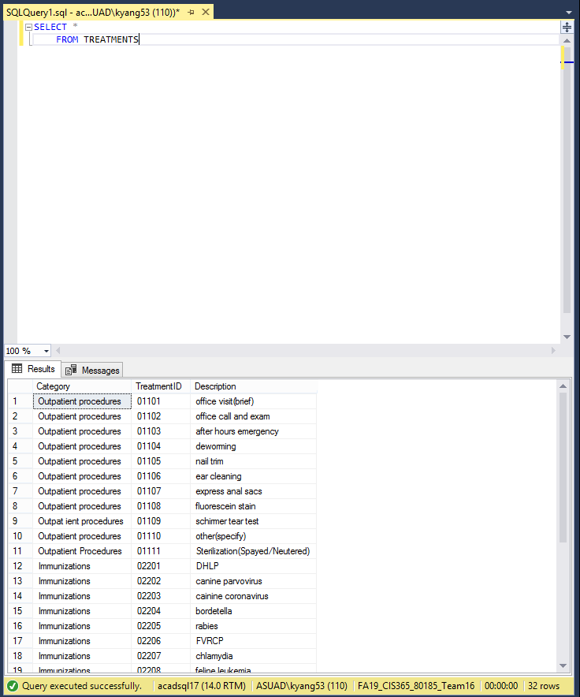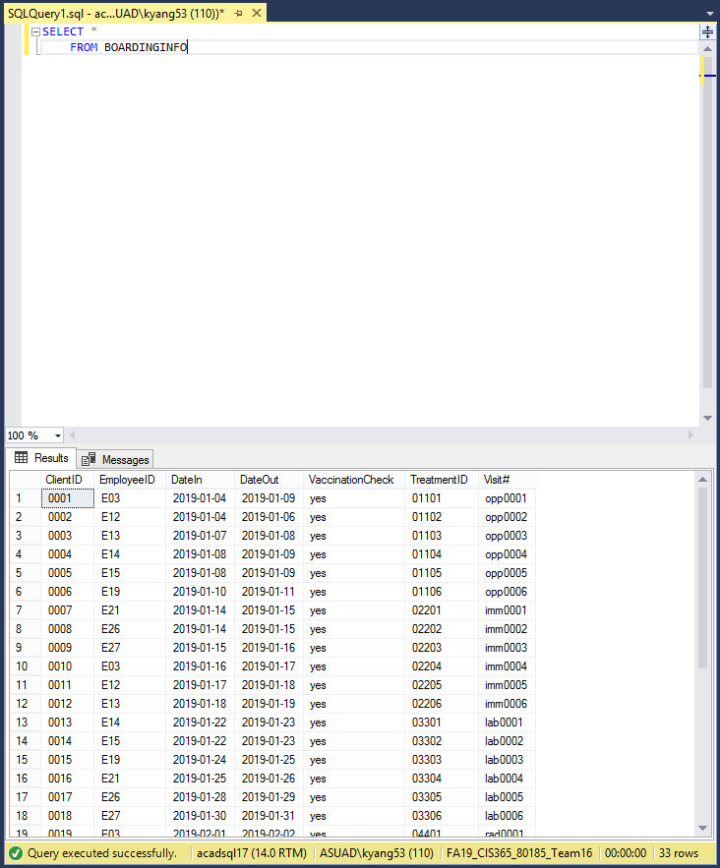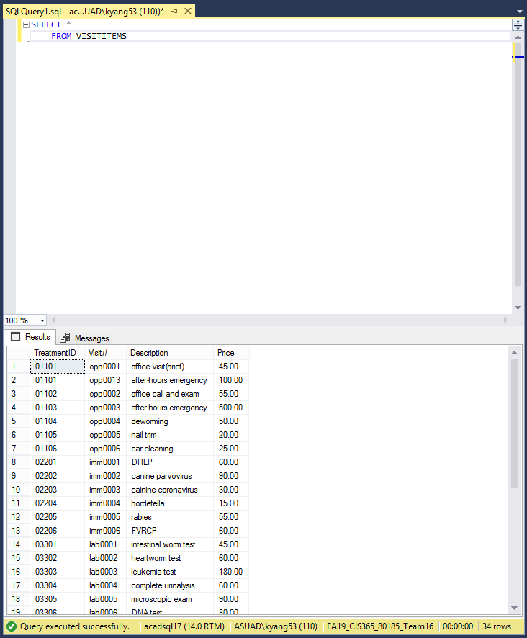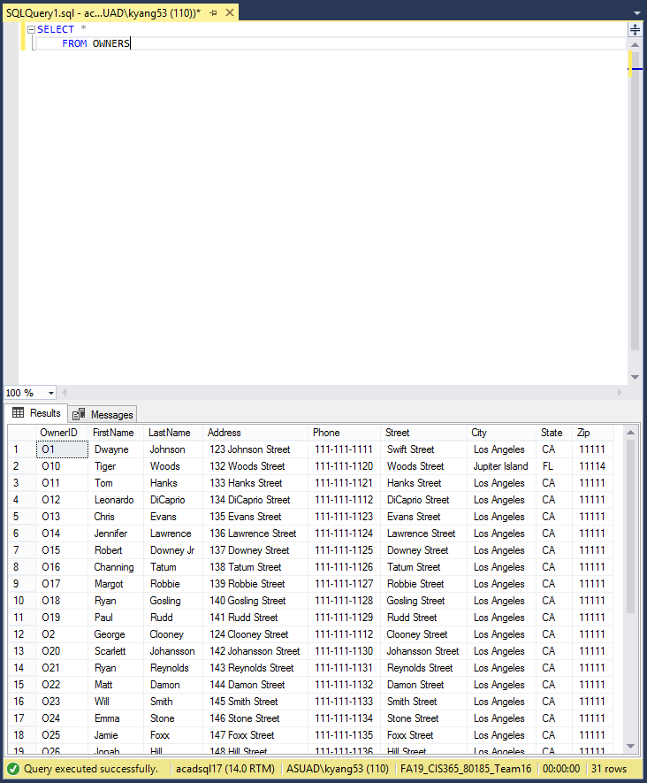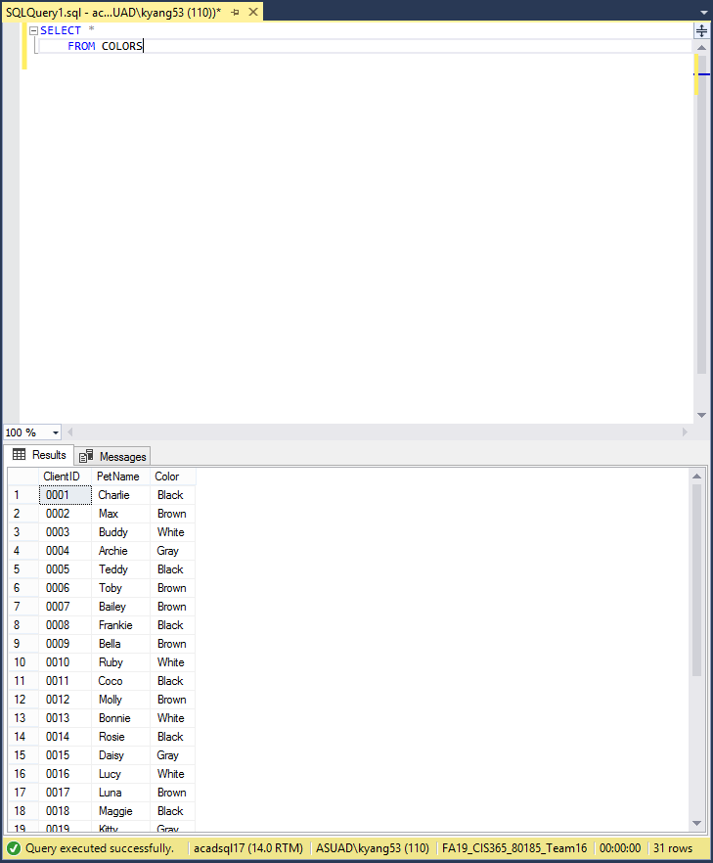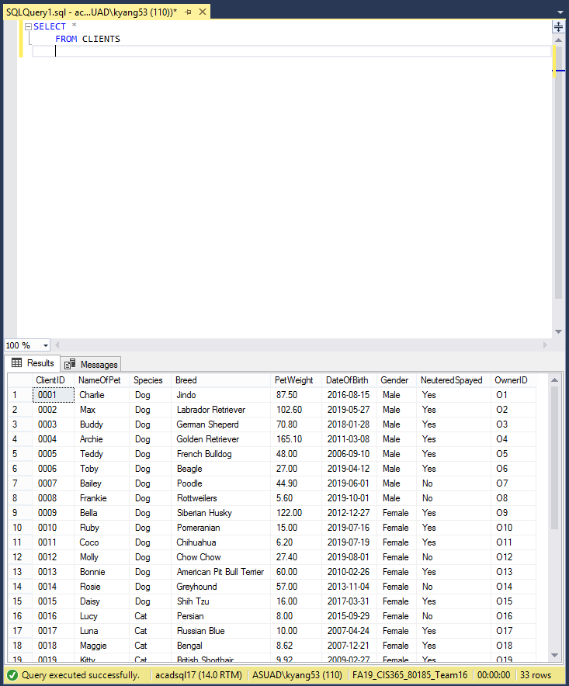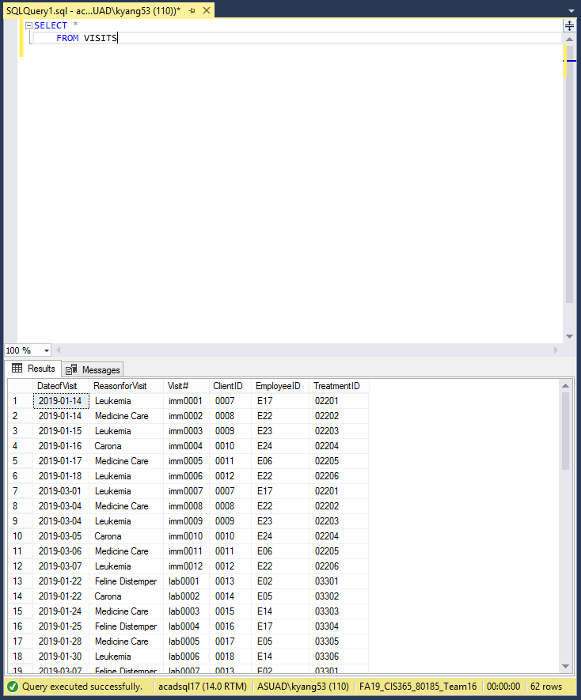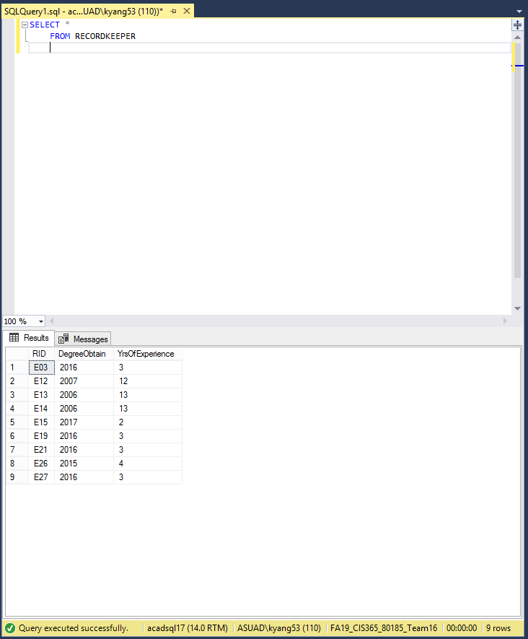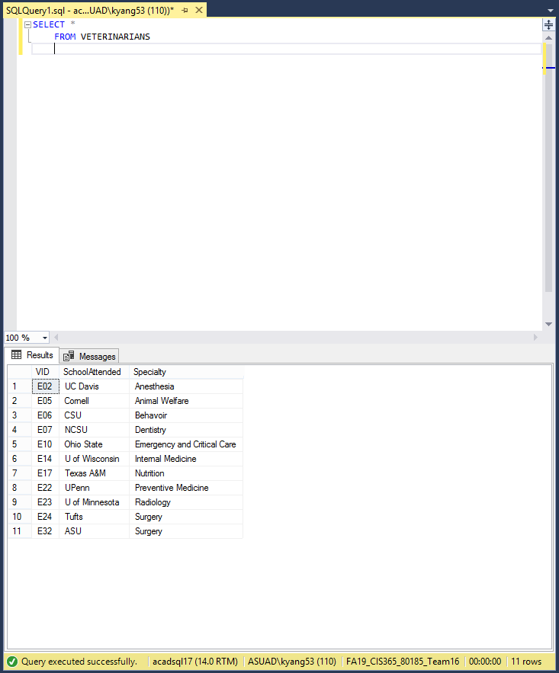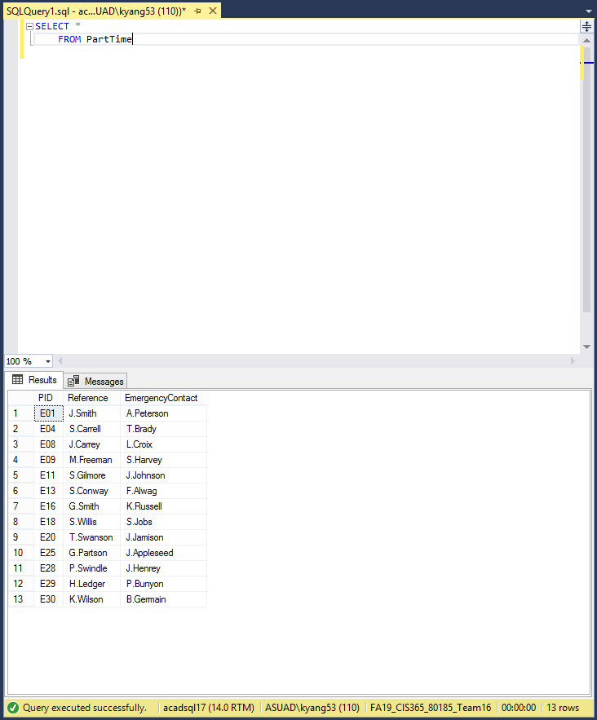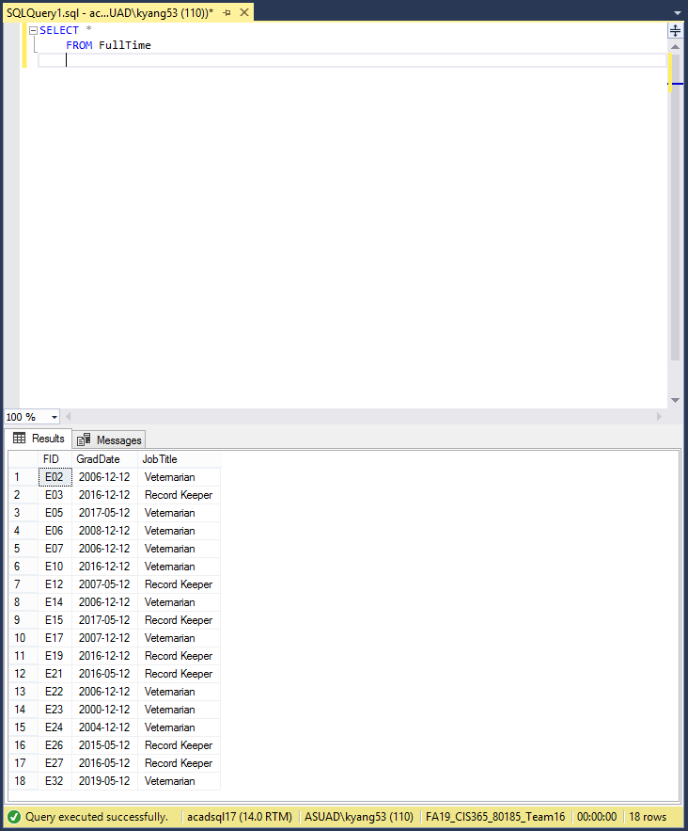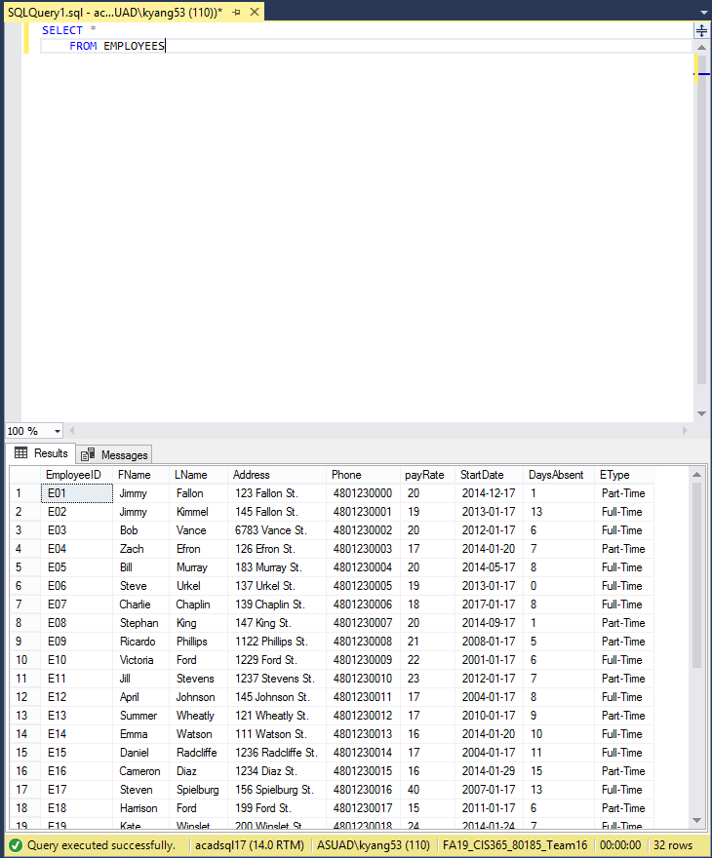

**Database Queries**

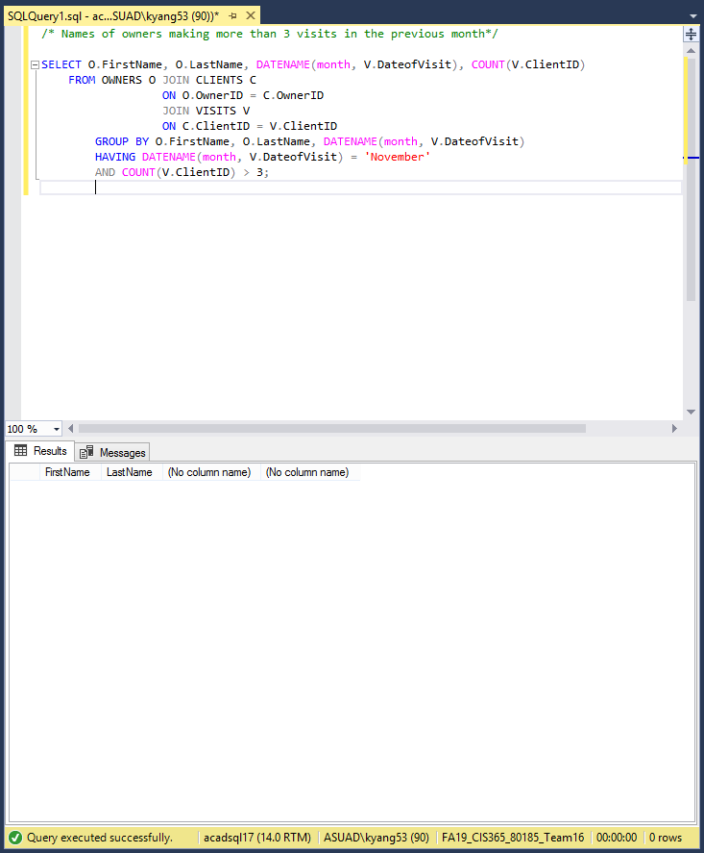

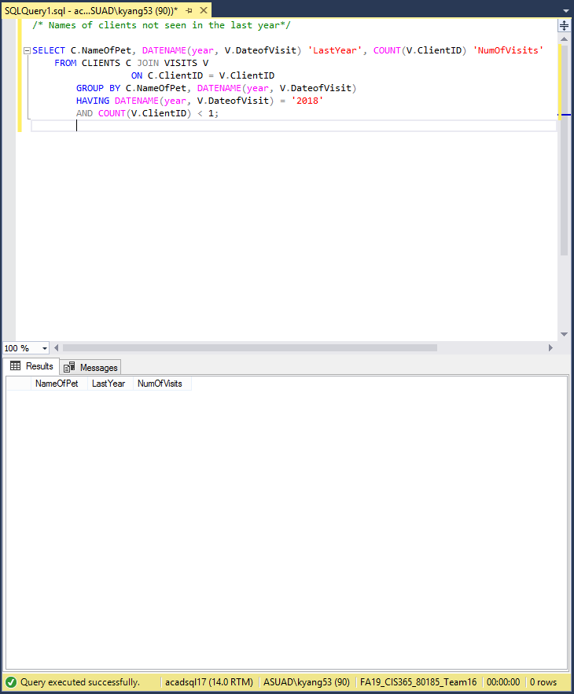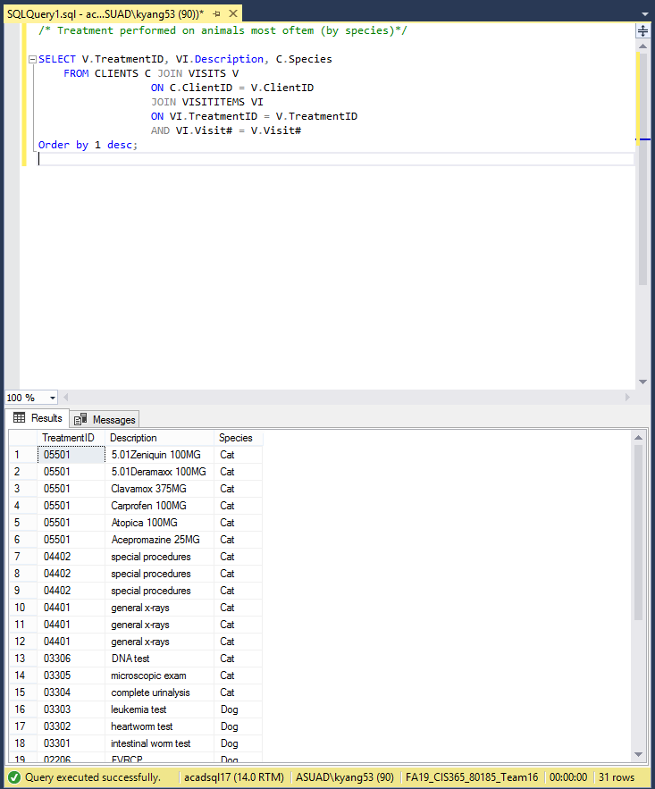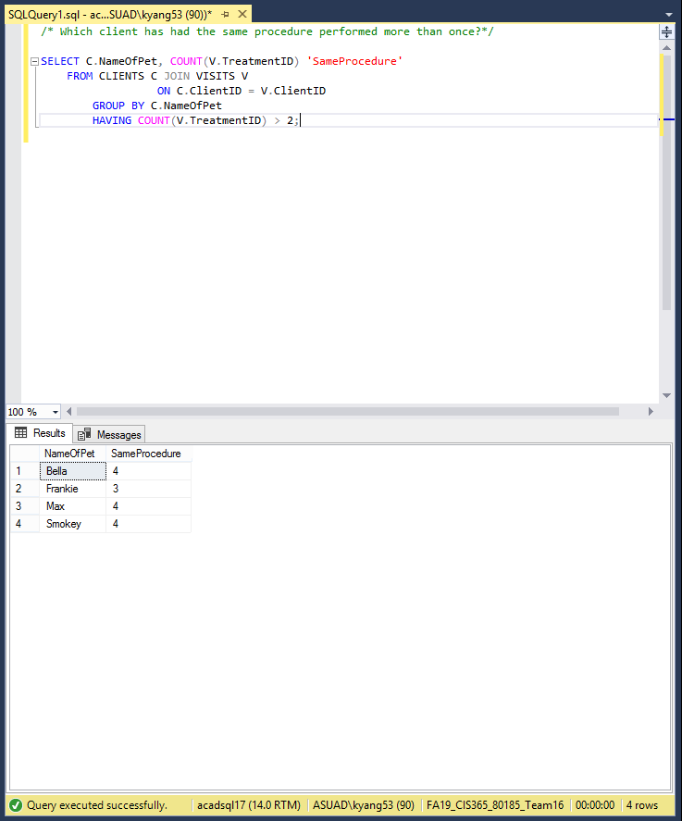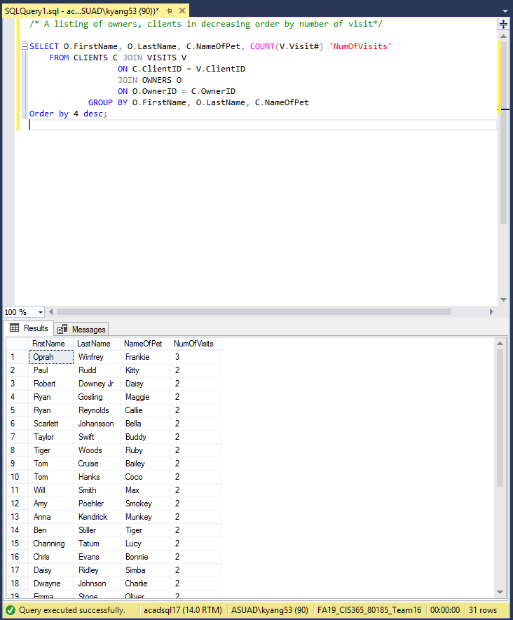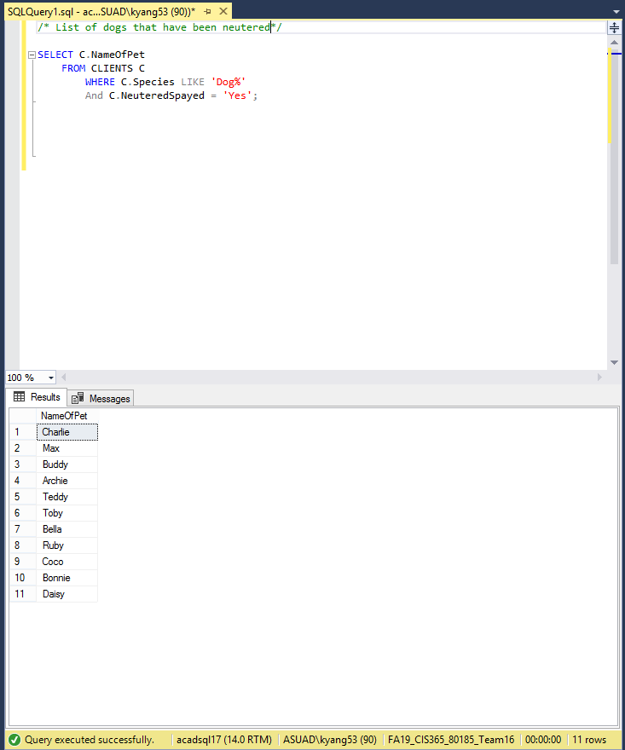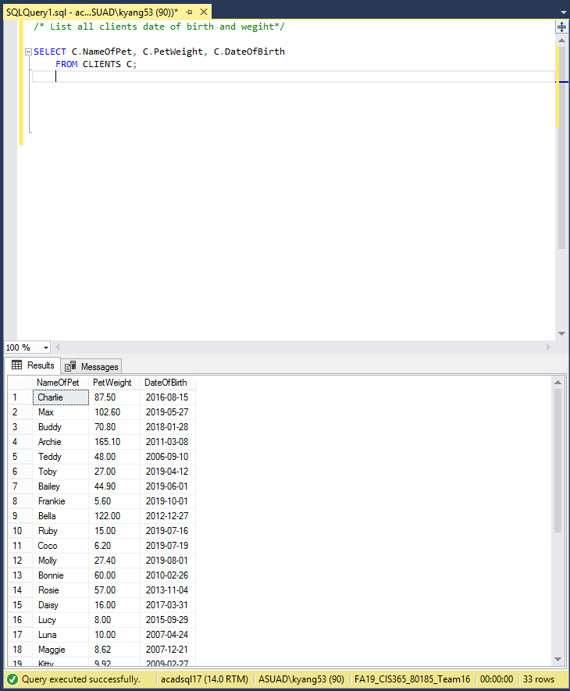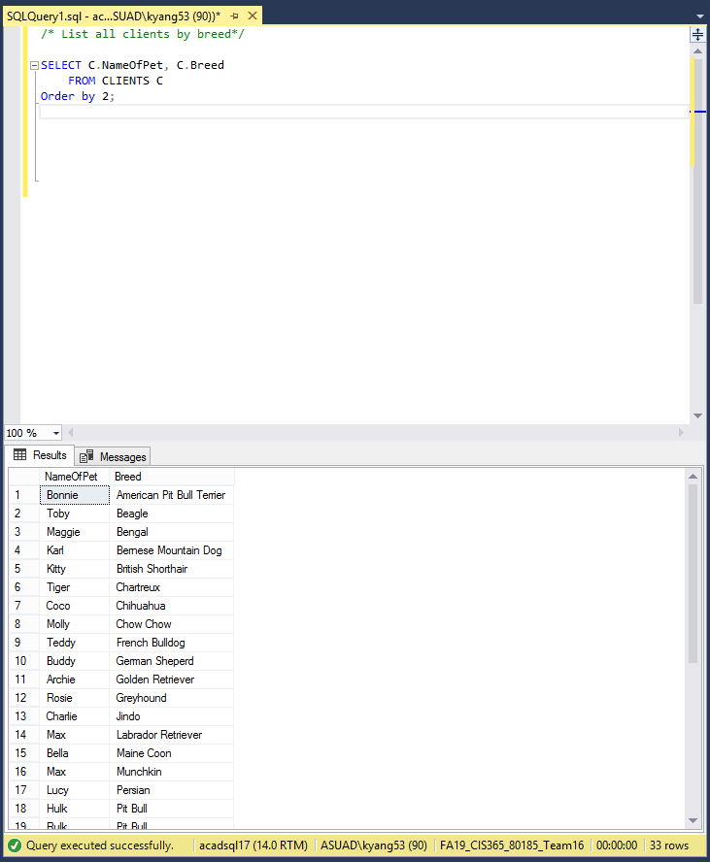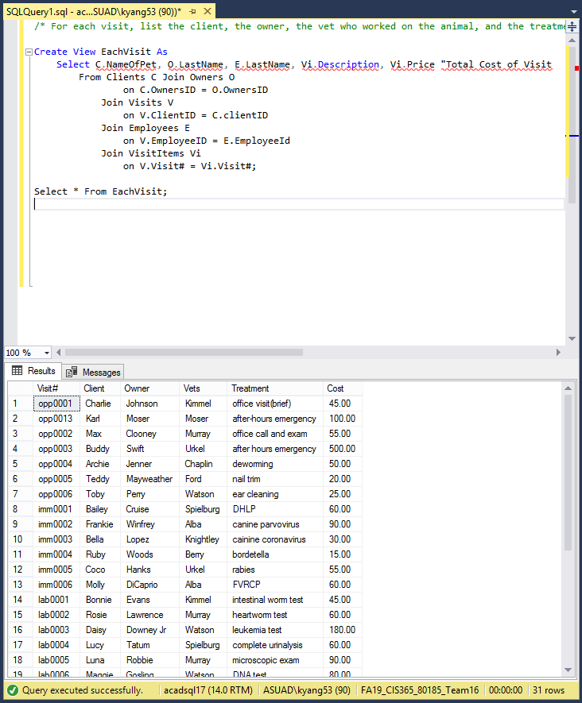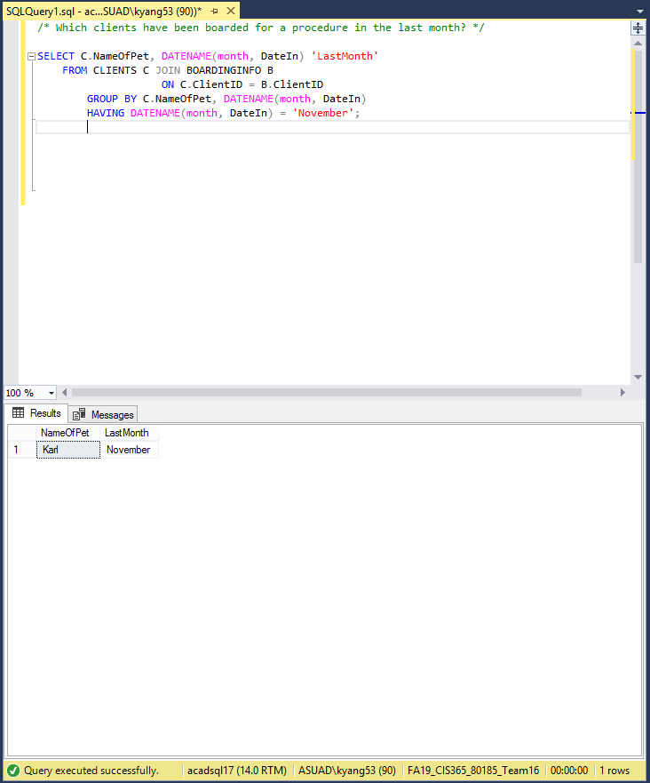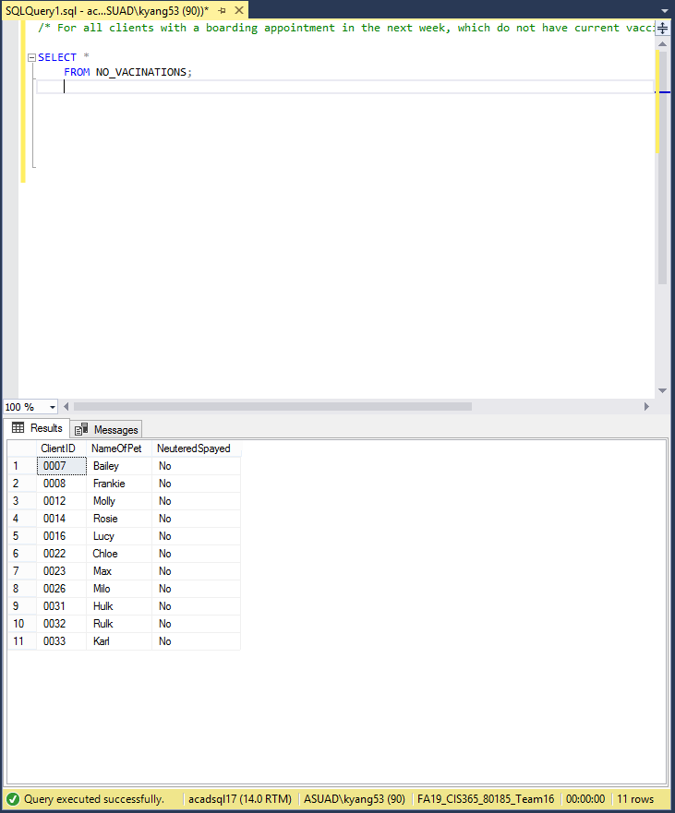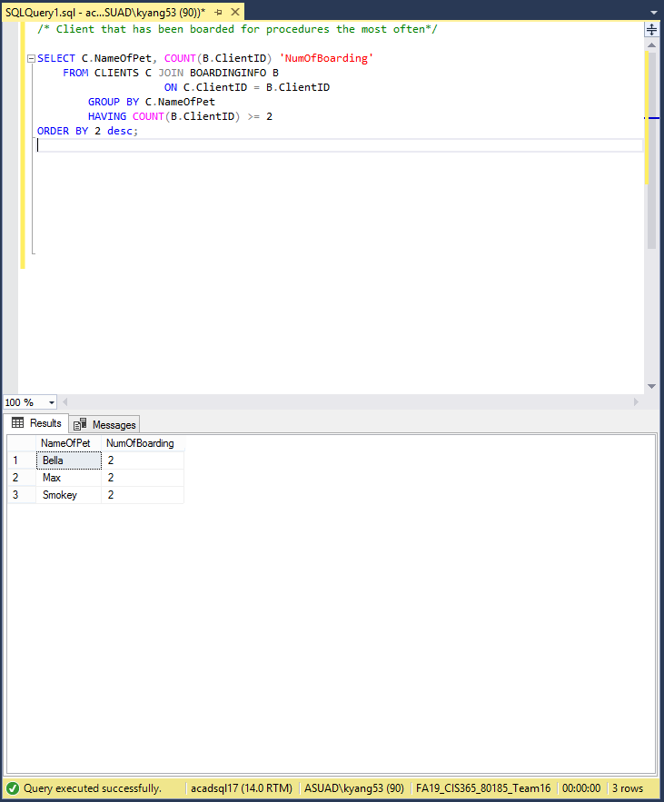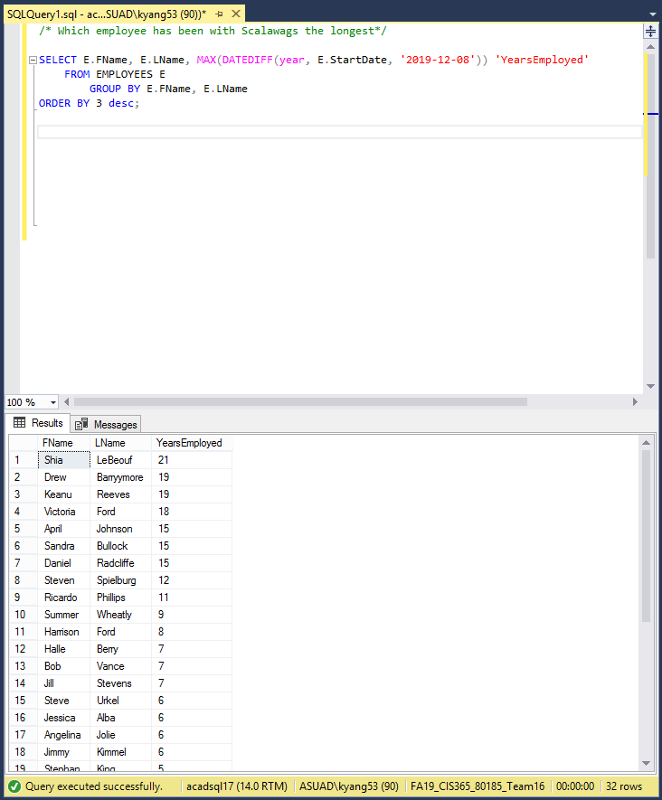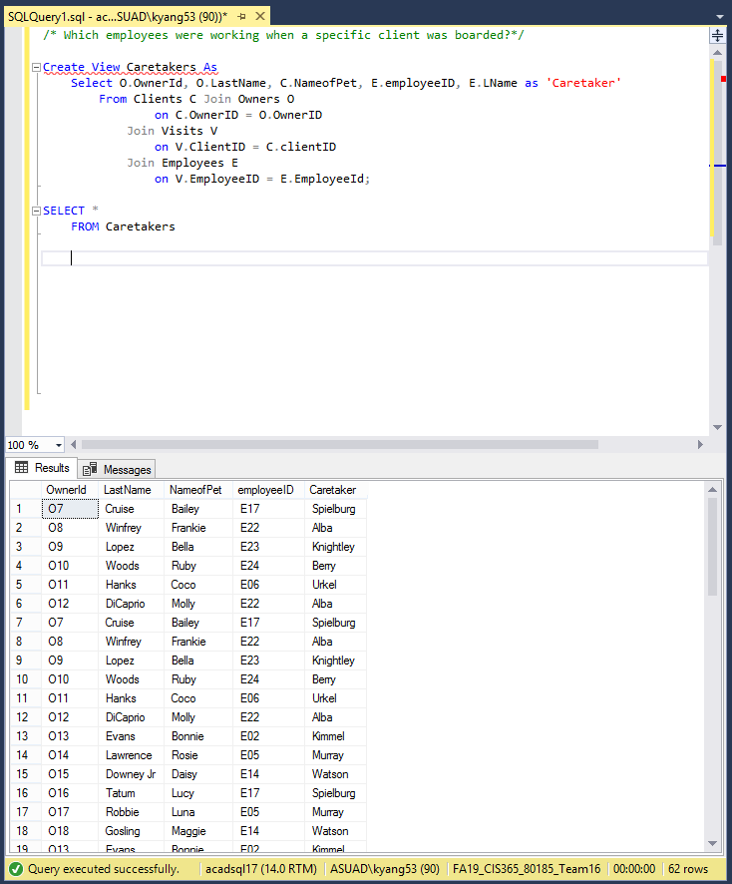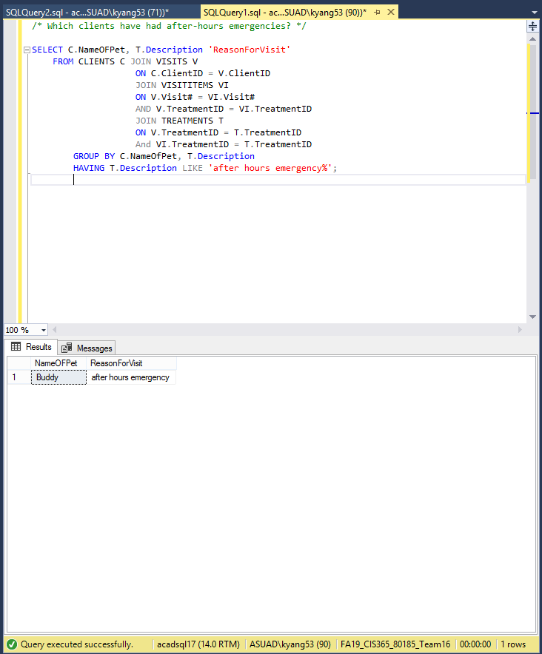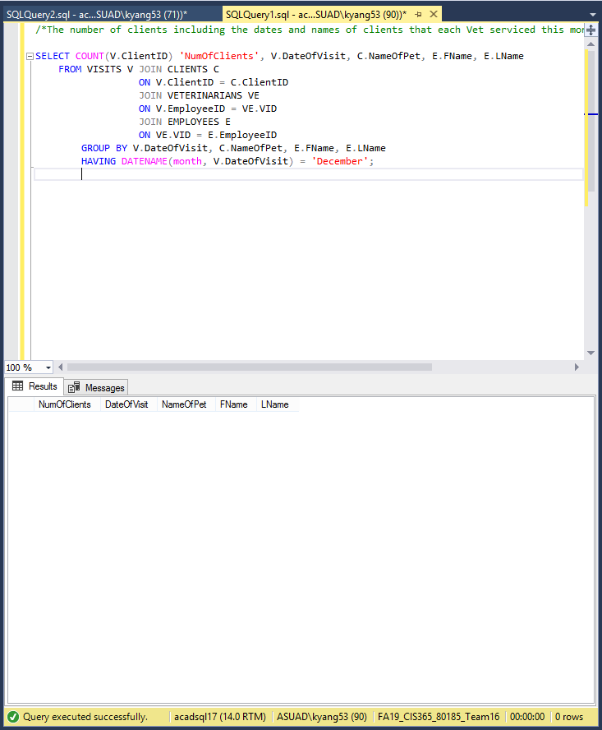

**Data Visualization**

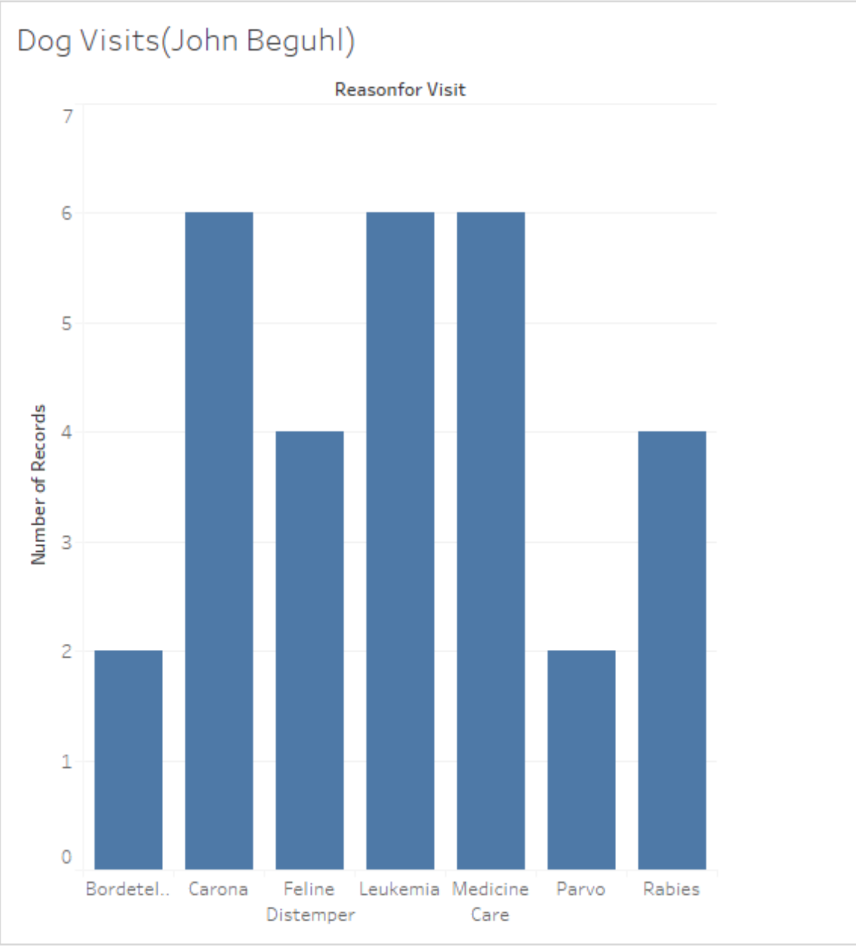

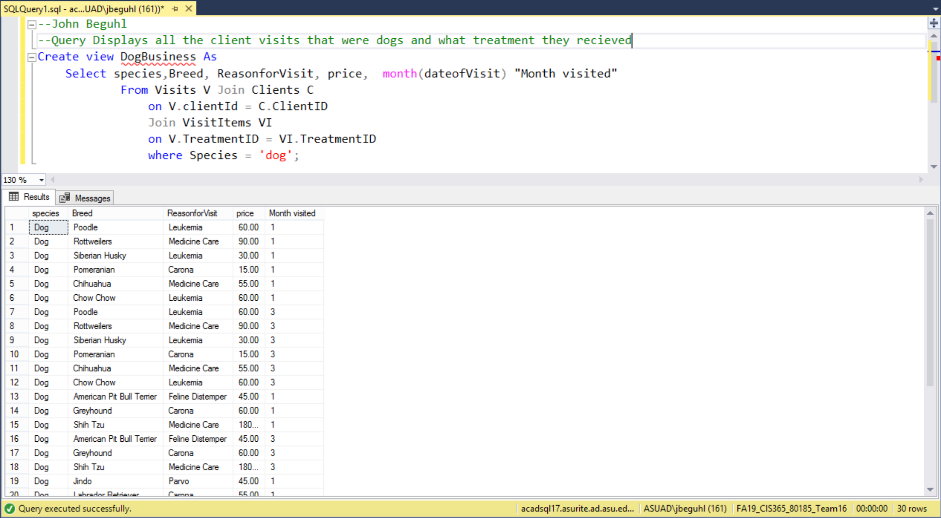

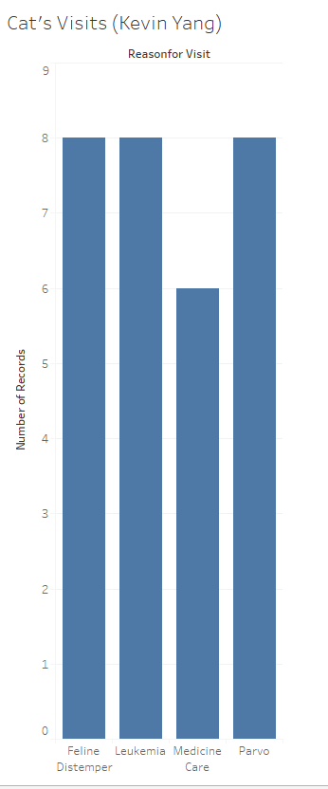

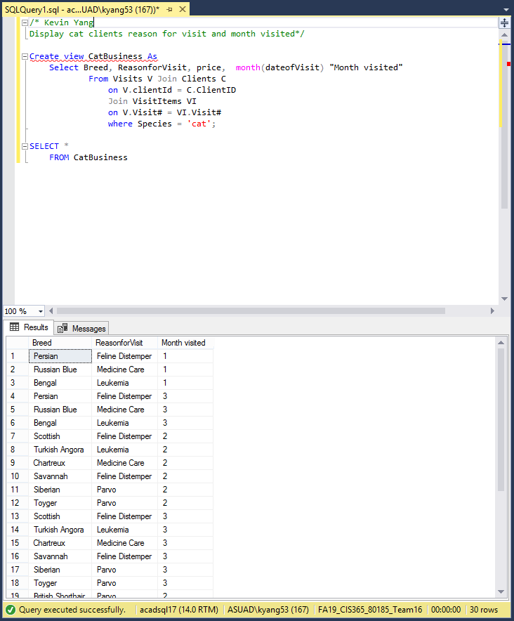

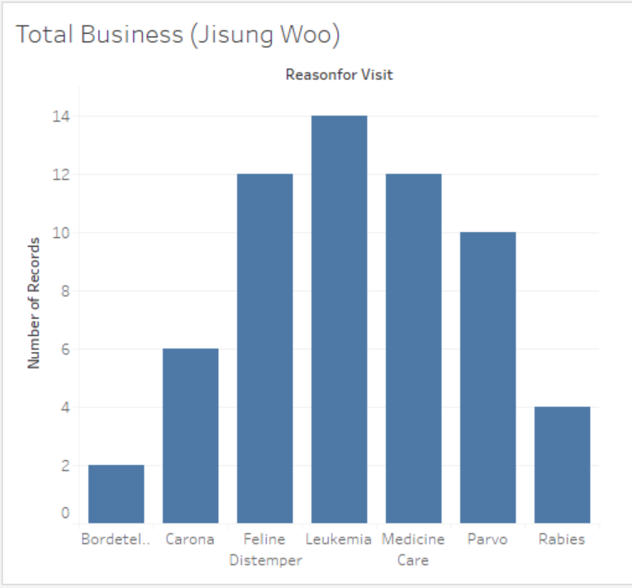

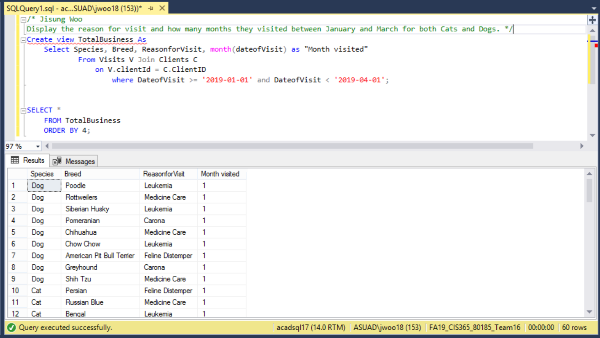

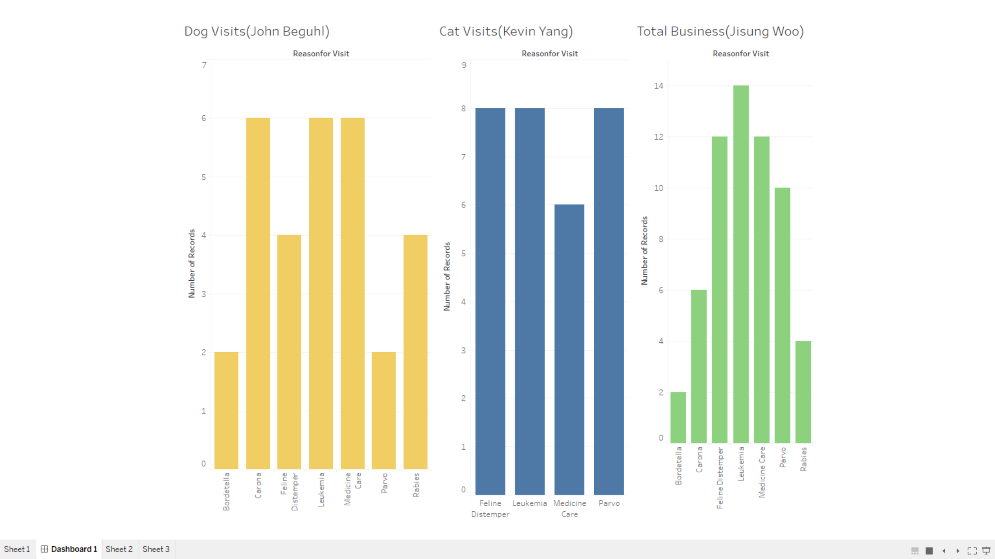

**Team Challenges**

Our team faced multiple challenges this semester unlike other groups we lost half of our members, three out of six, throughout the course of the semester. The first member that we lost was not a huge deal because he dropped the class before we even submitted milestone one. However, later on in the semester when two additional members dropped the course it had a much greater impact on the group. We had become dependent on the work that they had been contributing to the team. It was hard to adjust to the new workload. We had to meet much more often and for longer periods of time. Another challenge that we faced was, like most groups, communication. Early in the semester we had poor communication skills within our group. It culminated in the late submission of our first milestone. Moving forward from there we resolved to meet more often and to be more organized. Additionally, we resolved to always respond to our group chat. Finally, our last major challenge we faced was everything SQL. Most of our problems with SQL stemmed from our unfamiliarity with this new topic. As a team we agreed that we would make it a priority to finish homework assignments first before we started the next milestone. This way we all had a grasp of the concepts that we were about to implement into our team database.

**Lessons Learned**

As a team we learned several valuable lessons throughout the course of the semester. First and foremost, we learned a lot about SQL. We were very proud of the fact that after a semester of learning about databases we were able to convert a couple pages of requirements from our client into the report that you are reading now. Additionally, our group learned to be flexible in a team setting. We had to be able to adapt to the loss of half of our team. Being flexible allowed us to adapt to the different ebbs and flows of the semester. Furthermore, we learned the importance of organization. This concept became very clear to us halfway through the semester after we realized how many files that we had created thus far. We learned to keep our team google drive very organized so that everyone could access files quickly.

Our advice for future CIS 365 students is this: 1) Get to know your teammates early on in the semester. This will make it much easier to work effectively with them. 2) Communicate well. If you communicate well within your team it will ensure less mistakes and less confusion. 3) When it comes time to write the scripts for your database meet before and make sure that everyone knows which datatypes to use and what to use for your primary and foreign keys. And finally 4) Don’t wait until the last minute to start each milestone. Start early! This helps to decrease the stress and also gives you more time in case technical errors arise.

**Appendix A**

/* Create Table */

/* CREATE, INSERT, AND DISPLAY THE CONTENTS OF THE Employee TABLE */

create table EMPLOYEES (

EmployeeID char(4),

FName varchar(20) Not null,

LName varchar(20) Not null,

Address varchar(25) Not null,

Phone char(12) Not null,

payRate smallint Not null,

StartDate Date Not null,

DaysAbsent smallint Not null,

EType varchar(15) Not null,

Primary Key (EmployeeID));

insert into EMPLOYEES values ('E01' , 'Jimmy' , 'Fallon' , '123 Fallon St.' , '4801230000' , 20 , '12/17/2014' , 1 , 'Part-Time');

insert into EMPLOYEES values ('E02' , 'Jimmy' , 'Kimmel' , '145 Fallon St.' , '4801230001' , 19 , '1/17/2013' , 13 , 'Full-Time');

insert into EMPLOYEES values ('E03' , 'Bob' , 'Vance' , '6783 Vance St.' , '4801230002' , 20 , '1/17/2012' , 6 , 'Full-Time');

insert into EMPLOYEES values ('E04' , 'Zach' , 'Efron' , '126 Efron St.' , '4801230003' , 17 , '1/20/2014' , 6 , 'Part-Time');

insert into EMPLOYEES values ('E05' , 'Bill' , 'Murray' , '183 Murray St.' , '4801230004' , 20 , '5/17/2014' , 8 , 'Full-Time');

insert into EMPLOYEES values ('E06' , 'Steve' , 'Urkel' , '137 Urkel St.' , '4801230005' , 19 , '1/17/2013' , 0 , 'Full-Time');

insert into EMPLOYEES values ('E07' , 'Charlie' , 'Chaplin' , '139 Chaplin St.' , '4801230006' , 18 , '1/17/2017' , 8 , 'Full-Time');

insert into EMPLOYEES values ('E08' , 'Stephan' , 'King' , '147 King St.' , '4801230007' , 20 , '9/17/2014' , 1 , 'Part-Time');

insert into EMPLOYEES values ('E09' , 'Ricardo' , 'Phillips' , '1122 Phillips St.' , '4801230008' , 21 , '1/17/2008' , 4 , 'Part-Time');

insert into EMPLOYEES values ('E10' , 'Victoria' , 'Ford' , '1229 Ford St.' , '4801230009' , 22 , '1/17/2001' , 6 , 'Full-Time');

insert into EMPLOYEES values ('E11' , 'Jill' , 'Stevens' , '1237 Stevens St.' , '4801230010' , 23 , '1/17/2012' , 7 , 'Part-Time');

insert into EMPLOYEES values ('E12' , 'April' , 'Johnson' , '145 Johnson St.' , '4801230011' , 17 , '1/17/2004' , 8 , 'Full-Time');

insert into EMPLOYEES values ('E13' , 'Summer' , 'Wheatly' , '121 Wheatly St.' , '4801230012' , 17 , '1/17/2010' , 9 , 'Part-Time');

insert into EMPLOYEES values ('E14' , 'Emma' , 'Watson' , '111 Watson St.' , '4801230013' , 16 , '1/20/2014' , 10 , 'Full-Time');

insert into EMPLOYEES values ('E15' , 'Daniel' , 'Radcliffe' , '1236 Radcliffe St.' , '4801230014' , 17 , '1/17/2004' , 11 , 'Full-Time');

insert into EMPLOYEES values ('E16' , 'Cameron' , 'Diaz' , '1234 Diaz St.' , '4801230015' , 16 , '1/29/2014' , 15 , 'Part-Time');

insert into EMPLOYEES values ('E17' , 'Steven' , 'Spielburg' , '156 Spielburg St.' , '4801230016' , 40 , '1/17/2007' , 13 , 'Full-Time');

insert into EMPLOYEES values ('E18' , 'Harrison' , 'Ford' , '199 Ford St.' , '4801230017' , 15 , '1/17/2011' , 6 , 'Part-Time');

insert into EMPLOYEES values ('E19' , 'Kate' , 'Winslet' , '200 Winslet St.' , '4801230018' , 24 , '1/24/2014' , 7 , 'Full-Time');

insert into EMPLOYEES values ('E20' , 'Natalie' , 'Portman' , '600 Portman St.' , '4801230019' , 16 , '8/17/2014' , 20 , 'Part-Time');

insert into EMPLOYEES values ('E21' , 'Angelina' , 'Jolie' , '567 Jolie St.' , '4801230020' , 18 , '5/23/2013' , 7 , 'Full-Time');

insert into EMPLOYEES values ('E22' , 'Jessica' , 'Alba' , '786 Alba St.' , '4801230021' , 19 , '10/17/2013' , 3 , 'Full-Time');

insert into EMPLOYEES values ('E23' , 'Keira' , 'Knightley' , '103 Knightley St.' , '4801230022' , 16 , '7/07/2014' , 1 , 'Full-Time');

insert into EMPLOYEES values ('E24' , 'Halle' , 'Berry' , '1209 Berry St.' , '4801230023' , 19 , '3/17/2012' , 12 , 'Full-Time');

insert into EMPLOYEES values ('E25' , 'Bruce' , 'Willis' , '1230 Willis St.' , '4801230024' , 15 , '5/17/2014' , 15 , 'Part-Time');

insert into EMPLOYEES values ('E26' , 'Sandra' , 'Bullock' , '1113 Bullock St.' , '4801230025' , 30 , '1/17/2004' , 10 , 'Full-Time');

insert into EMPLOYEES values ('E27' , 'Drew' , 'Barryymore' , '1000 Barryymore St.' , '4801230026' , 29 , '1/17/2000' , 0 , 'Full-Time');

insert into EMPLOYEES values ('E28' , 'Bruce' , 'Lee' , '100 Lee St.' , '4801230027' , 25 , '6/07/2014' , 0 , 'Part-Time');

insert into EMPLOYEES values ('E29' , 'Shia' , 'LeBeouf' , '128 LeBeouf St.' , '4801230028' , 50 , '1/17/1998' , 0 , 'Part-Time');

insert into EMPLOYEES values ('E30' , 'Keanu' , 'Reeves' , '127 Reeves St.' , '4801230029' , 45 , '1/17/2000' , 0 , 'Part-Time');

Select * From Employees;

===================================================================================================================================

/* CREATE, INSERT, AND DISPLAY THE CONTENTS OF THE Full-Time TABLE */

create table FullTime (

FID char(4) Not null,

GradDate Date Not null,

JobTitle varchar(15) Not null,

Primary Key (FID));

insert into FullTime values('E02' , '12/12/2006' , 'Veternarian');

insert into FullTime values('E03' , '12/12/2016' , 'Record Keeper');

insert into FullTime values('E05' , '5/12/2017' , 'Veternarian');

insert into FullTime values('E06' , '12/12/2008' , 'Veternarian');

insert into FullTime values('E07' , '12/12/2006' , 'Veternarian');

insert into FullTime values('E10' , '12/12/2016' , 'Veternarian');

insert into FullTime values('E12' , '5/12/2007' , 'Record Keeper');

insert into FullTime values('E14' , '12/12/2006' , 'Veternarian');

insert into FullTime values('E15' , '5/12/2017' , 'Record Keeper');

insert into FullTime values('E17' , '12/12/2007' , 'Veternarian');

insert into FullTime values('E19' , '12/12/2016' , 'Record Keeper');

insert into FullTime values('E21' , '5/12/2016' , 'Record Keeper');

insert into FullTime values('E22' , '12/12/2006' , 'Veternarian');

insert into FullTime values('E23' , '12/12/2000' , 'Veternarian');

insert into FullTime values('E24' , '12/12/2004' , 'Veternarian');

insert into FullTime values('E26' , '5/12/2015' , 'Record Keeper');

insert into FullTime values('E27' , '5/12/2016' , 'Record Keeper');

Select * From FullTime;

=========================================================================================================================================================

/* CREATE, INSERT, AND DISPLAY THE CONTENTS OF THE Part-Time TABLE */

create table PartTime (

PID char(4) Not null,

Reference varchar(15) Not null,

EmergencyContact varchar(15) Not null,

Primary Key (PID));

insert into PartTime values('E01' , 'J.Smith' , 'A.Peterson');

insert into PartTime values('E04' , 'S.Carrell' , 'T.Brady');

insert into PartTime values('E08' , 'J.Carrey' , 'L.Croix');

insert into PartTime values('E09' , 'M.Freeman' , 'S.Harvey');

insert into PartTime values('E11' , 'S.Gilmore' , 'J.Johnson');

insert into PartTime values('E13' , 'S.Conway' , 'F.Alwag');

insert into PartTime values('E16' , 'G.Smith' , 'K.Russell');

insert into PartTime values('E18' , 'S.Willis' , 'S.Jobs');

insert into PartTime values('E20' , 'T.Swanson' , 'J.Jamison');

insert into PartTime values('E25' , 'G.Partson' , 'J.Appleseed');

insert into PartTime values('E28' , 'P.Swindle' , 'J.Henrey');

insert into PartTime values('E29' , 'H.Ledger' , 'P.Bunyon');

insert into PartTime values('E30' , 'K.Wilson' , 'B.Germain');

Select * From PartTime;

=============================================================================================================================

/* CREATE TABLES FOR SCALAWAGS VETERINARY CLINIC */

/* CREATE, INSERT, AND DISPLAY THE VETERINARIANS TABLE */

create table VETERINARIANS (

VID varchar(4),

SchoolAttended varchar(35) Not null,

Specialty varchar(35) Not null,

Primary Key (VID));

insert into VETERINARIANS values ('E02', 'UC Davis', 'Anesthesia');

insert into VETERINARIANS values ('E05', 'Cornell', 'Animal Welfare');

insert into VETERINARIANS values ('E06', 'CSU', 'Behavoir');

insert into VETERINARIANS values ('E07', 'NCSU', 'Dentistry');

insert into VETERINARIANS values ('E10', 'Ohio State', 'Emergency and Critical Care');

insert into VETERINARIANS values ('E14', 'U of Wisconsin', 'Internal Medicine');

insert into VETERINARIANS values ('E17', 'Texas A&M', 'Nutrition');

insert into VETERINARIANS values ('E22', 'UPenn', 'Preventive Medicine');

insert into VETERINARIANS values ('E23', 'U of Minnesota', 'Radiology');

insert into VETERINARIANS values ('E24', 'Tufts', 'Surgery');

Select * from VETERINARIANS;

==============================================================================================================================

/* Create, Insert, and Display the contents of the RECORD KEEPER Table */

create table RECORDKEEPER (

RID varchar(3),

DegreeObtain integer Not Null,

YrsOfExperience smallint Not Null,

Primary Key (RID));

insert into RECORDKEEPER values ('E03', 2016, 3);

insert into RECORDKEEPER values ('E12', 2007, 12);

insert into RECORDKEEPER values ('E13', 2006, 13);

insert into RECORDKEEPER values ('E14', 2006, 13);

insert into RECORDKEEPER values ('E15', 2017, 2);

insert into RECORDKEEPER values ('E19', 2016, 3);

insert into RECORDKEEPER values ('E21', 2016, 3);

insert into RECORDKEEPER values ('E26', 2015, 4);

insert into RECORDKEEPER values ('E27', 2016, 3);

SELECT * FROM RECORDKEEPER;

==================================================================================================================================

/* Script for Owners and Colors */

/* Create, Insert, and Display the contents of the OWNERS Table */

create table OWNERS (

OwnerID varchar(3),

FirstName varchar(10) Not null,

LastName varchar(15) Not null,

Address varchar(30) Not null,

Phone char(12) Not null,

Street varchar(25) Not null,

City varchar(20) Not null,

State char(2) Not null,

Zip char(5) Not null,

Primary Key (OwnerID));

insert into OWNERS values ('O1', 'Dwayne', 'Johnson', '123 Johnson Street', '111-111-1111', 'Swift Street', 'Los Angeles', 'CA', '11111');

insert into OWNERS values ('O2', 'George', 'Clooney', '124 Clooney Street', '111-111-1112', 'Clooney Street', 'Los Angeles', 'CA', '11111');

insert into OWNERS values ('O3', 'Taylor', 'Swift', '125 Swift Street', '111-111-1113', 'Swift Street', 'Nashville', 'TN', '11113');

insert into OWNERS values ('O4', 'Kylie', 'Jenner', '126 Jenner Street', '111-111-1114', 'Jenner Street', 'Los Angeles', 'CA', '11111');

insert into OWNERS values ('O5', 'Floyd', 'Mayweather', '127 Mayweather Street', '111-111-1115', 'Mayweather Street', 'Las Vegas', 'NV', '11115');

insert into OWNERS values ('O6', 'Katy', 'Perry', '128 Perry Street', '111-111-1116', 'Perry Street', 'Los Angeles', 'CA', '11111');

insert into OWNERS values ('O7', 'Tom', 'Cruise', '129 Cruise Street', '111-111-1117', 'Cruise Street', 'Los Angeles', 'CA', '11111');

insert into OWNERS values ('O8', 'Oprah', 'Winfrey', '130 Winfrey Street', '111-111-1118', 'Winfrey Street', 'New York', 'NY', '11112');

insert into OWNERS values ('O9', 'Jennifer', 'Lopez', '131 Lopez Street', '111-111-1119', 'Lopez Street', 'Los Angeles', 'CA', '11111');

insert into OWNERS values ('O10', 'Tiger', 'Woods', '132 Woods Street', '111-111-1120', 'Woods Street', 'Jupiter Island', 'FL', '11114');

insert into OWNERS values ('O11', 'Tom', 'Hanks', '133 Hanks Street', '111-111-1121', 'Hanks Street', 'Los Angeles', 'CA', '11111');

insert into OWNERS values ('O12', 'Leonardo', 'DiCaprio', '134 DiCaprio Street', '111-111-1112', 'DiCaprio Street', 'Los Angeles', 'CA', '11111');

insert into OWNERS values ('O13', 'Chris', 'Evans', '135 Evans Street', '111-111-1123', 'Evans Street', 'Los Angeles', 'CA', '11111');

insert into OWNERS values ('O14', 'Jennifer', 'Lawrence', '136 Lawrence Street', '111-111-1124', 'Lawrence Street', 'Los Angeles', 'CA', '11111');

insert into OWNERS values ('O15', 'Robert', 'Downey Jr', '137 Downey Street', '111-111-1125', 'Downey Street', 'Los Angeles', 'CA', '11111');

insert into OWNERS values ('O16', 'Channing', 'Tatum', '138 Tatum Street', '111-111-1126', 'Tatum Street', 'Los Angeles', 'CA', '11111');

insert into OWNERS values ('O17', 'Margot', 'Robbie', '139 Robbie Street', '111-111-1127', 'Robbie Street', 'Los Angeles', 'CA', '11111');

insert into OWNERS values ('O18', 'Ryan', 'Gosling', '140 Gosling Street', '111-111-1128', 'Gosling Street', 'Los Angeles', 'CA', '11111');

insert into OWNERS values ('O19', 'Paul', 'Rudd', '141 Rudd Street', '111-111-1129', 'Rudd Street', 'Los Angeles', 'CA', '11111');

insert into OWNERS values ('O20', 'Scarlett', 'Johansson', '142 Johansson Street', '111-111-1130', 'Johansson Street', 'Los Angeles', 'CA', '11111');

insert into OWNERS values ('O21', 'Ryan', 'Reynolds', '143 Reynolds Street', '111-111-1131', 'Reynolds Street', 'Los Angeles', 'CA', '11111');

insert into OWNERS values ('O22', 'Matt', 'Damon', '144 Damon Street', '111-111-1132', 'Damon Street', 'Los Angeles', 'CA', '11111');

insert into OWNERS values ('O23', 'Will', 'Smith', '145 Smith Street', '111-111-1133', 'Smith Street', 'Los Angeles', 'CA', '11111');

insert into OWNERS values ('O24', 'Emma', 'Stone', '146 Stone Street', '111-111-1134', 'Stone Street', 'Los Angeles', 'CA', '11111');

insert into OWNERS values ('O25', 'Jamie', 'Foxx', '147 Foxx Street', '111-111-1135', 'Foxx Street', 'Los Angeles', 'CA', '11111');

insert into OWNERS values ('O26', 'Jonah', 'Hill', '148 Hill Street', '111-111-1136', 'Hill Street', 'Los Angeles', 'CA', '11111');

insert into OWNERS values ('O27', 'Ben', 'Stiller', '149 Stiller Street', '111-111-1137', 'Stiller Street', 'Los Angeles', 'CA', '11111');

insert into OWNERS values ('O28', 'Daisy', 'Ridley', '150 Ridley Street', '111-111-1138', 'Ridley Street', 'Los Angeles', 'CA', '11111');

insert into OWNERS values ('O29', 'Amy', 'Poehler', '151 Poehler Street', '111-111-1139', 'Poehler Street', 'Los Angeles', 'CA', '11111');

insert into OWNERS values ('O30', 'Anna', 'Kendrick', '152 Kendrick Street', '111-111-1140', 'Kendrick Street', 'Los Angeles', 'CA', '11111');

SELECT * from OWNERS;

======================================================================================================================================================

/* Script for Clients and Record Keeper */

/* Create, Insert, and Display the contents of the CLIENTS Table */

create table CLIENTS (

ClientID char(4),

NameOfPet varchar(15) Not null,

Species varchar(4) Not null,

Breed varchar(25) Not null,

PetWeight decimal(5,2) Not null,

DateOfBirth Date Not null,

Gender varchar(6) Not Null,

NeuteredSpayed varchar(3) Not Null,

OwnerID varchar(3) Not Null,

Primary Key (ClientId),

Foreign Key (OwnerID) REFERENCES OWNERS (OwnerID));

insert into CLIENTS values ('0001', 'Charlie', 'Dog', 'Jindo', 87.5, '15-Aug-16', 'Male', 'Yes', 'O1');

insert into CLIENTS values ('0002', 'Max', 'Dog', 'Labrador Retriever', 102.6, '27-May-19', 'Male', 'Yes', 'O2');

insert into CLIENTS values ('0003', 'Buddy', 'Dog', 'German Sheperd', 70.8, '28-Jan-18', 'Male', 'Yes', 'O3');

insert into CLIENTS values ('0004', 'Archie', 'Dog', 'Golden Retriever', 165.1, '8-Mar-11', 'Male', 'Yes', 'O4');

insert into CLIENTS values ('0005', 'Teddy', 'Dog', 'French Bulldog', 48, '10-Sep-06', 'Male', 'Yes', 'O5');

insert into CLIENTS values ('0006', 'Toby', 'Dog', 'Beagle', 27, '12-Apr-19', 'Male', 'Yes', 'O6');

insert into CLIENTS values ('0007', 'Bailey', 'Dog', 'Poodle', 44.9, '1-Jun-19', 'Male', 'No', 'O7');

insert into CLIENTS values ('0008', 'Frankie', 'Dog', 'Rottweilers', 5.6, '1-Oct-19', 'Male', 'No', 'O8');

insert into CLIENTS values ('0009', 'Bella', 'Dog', 'Siberian Husky', 122, '27-Dec-12', 'Female', 'Yes', 'O9');

insert into CLIENTS values ('0010', 'Ruby', 'Dog', 'Pomeranian', 15, '16-Jul-19', 'Female', 'Yes', 'O10');

insert into CLIENTS values ('0011', 'Coco', 'Dog', 'Chihuahua', 6.2, '19-Jul-19', 'Female', 'Yes', 'O11');

insert into CLIENTS values ('0012', 'Molly', 'Dog', 'Chow Chow', 27.4, '1-Aug-19', 'Female', 'No', 'O12');

insert into CLIENTS values ('0013', 'Bonnie', 'Dog', 'American Pit Bull Terrier', 60, '26-Feb-10', 'Female', 'Yes', 'O13');

insert into CLIENTS values ('0014', 'Rosie', 'Dog', 'Greyhound', 57, '4-Nov-13', 'Female', 'No', 'O14');

insert into CLIENTS values ('0015', 'Daisy', 'Dog', 'Shih Tzu', 16, '31-Mar-17', 'Female', 'Yes', 'O15');

insert into CLIENTS values ('0016', 'Lucy', 'Cat', 'Persian', 8, '29-Sep-15', 'Female', 'No', 'O16');

insert into CLIENTS values ('0017', 'Luna', 'Cat', 'Russian Blue', 10, '24-Apr-07', 'Female', 'Yes', 'O17');

insert into CLIENTS values ('0018', 'Maggie', 'Cat', 'Bengal', 8.62, '21-Dec-07', 'Female', 'Yes', 'O18');

insert into CLIENTS values ('0019', 'Kitty', 'Cat', 'British Shorthair', 9.92, '27-Feb-09', 'Female', 'Yes', 'O19');

insert into CLIENTS values ('0020', 'Bella', 'Cat', 'Maine Coon', 7.97, '28-Aug-09', 'Female', 'Yes', 'O20');

insert into CLIENTS values ('0021', 'Callie', 'Cat', 'Sphynx', 8.26, '9-Oct-11', 'Female', 'Yes', 'O21');

insert into CLIENTS values ('0022', 'Chloe', 'Cat', 'Siamese', 2.6, '1-Oct-19', 'Female', 'No', 'O22');

insert into CLIENTS values ('0023', 'Max', 'Cat', 'Munchkin', 10.6, '10-Oct-11', 'Male', 'No', 'O23');

insert into CLIENTS values ('0024', 'Oliver', 'Cat', 'Ragdoll', 4.65, '7-Sep-19', 'Male', 'Yes', 'O24');

insert into CLIENTS values ('0025', 'Smokey', 'Cat', 'Scottish', 7.23, '13-Jan-12', 'Male', 'Yes', 'O25');

insert into CLIENTS values ('0026', 'Milo', 'Cat', 'Turkish Angora', 9.14, '30-May-16', 'Male', 'No', 'O26');

insert into CLIENTS values ('0027', 'Tiger', 'Cat', 'Chartreux', 6.87, '24-Aug-18', 'Male', 'Yes', 'O27');

insert into CLIENTS values ('0028', 'Simba', 'Cat', 'Savannah', 7.12, '5-Nov-18', 'Male', 'Yes', 'O28');

insert into CLIENTS values ('0029', 'Smokey', 'Cat', 'Siberian', 8.83, '22-Mar-14', 'Male', 'Yes', 'O29');

insert into CLIENTS values ('0030', 'Munkey', 'Cat', 'Toyger', 8.58, '9-Sep-17', 'Male', 'Yes', 'O30');

SELECT * FROM CLIENTS;

============================================================================================================================

/* Create, Insert, and Display the contents of the OWNERS Table */

create table COLORS (

ClientID char(4),

PetName varchar(15) Not null,

Color varchar(5) Not null,

Primary Key (ClientID, PetName),

Foreign Key (ClientID) REFERENCES CLIENTS (ClientID));

insert into COLORS values ('0001', 'Charlie', 'Black');

insert into COLORS values ('0002', 'Max', 'Brown');

insert into COLORS values ('0003', 'Buddy', 'White');

insert into COLORS values ('0004', 'Archie', 'Gray');

insert into COLORS values ('0005', 'Teddy', 'Black');

insert into COLORS values ('0006', 'Toby', 'Brown');

insert into COLORS values ('0007', 'Bailey', 'Brown');

insert into COLORS values ('0008', 'Frankie', 'Black');

insert into COLORS values ('0009', 'Bella', 'Brown');

insert into COLORS values ('0010', 'Ruby', 'White');

insert into COLORS values ('0011', 'Coco', 'Black');

insert into COLORS values ('0012', 'Molly', 'Brown');

insert into COLORS values ('0013', 'Bonnie', 'White');

insert into COLORS values ('0014', 'Rosie', 'Black');

insert into COLORS values ('0015', 'Daisy', 'Gray');

insert into COLORS values ('0016', 'Lucy', 'White');

insert into COLORS values ('0017', 'Luna', 'Brown');

insert into COLORS values ('0018', 'Maggie', 'Black');

insert into COLORS values ('0019', 'Kitty', 'Gray');

insert into COLORS values ('0020', 'Bella', 'Gray');

insert into COLORS values ('0021', 'Callie', 'Brown');

insert into COLORS values ('0022', 'Chloe', 'Black');

insert into COLORS values ('0023', 'Max', 'White');

insert into COLORS values ('0024', 'Oliver', 'Gray');

insert into COLORS values ('0025', 'Smokey', 'Black');

insert into COLORS values ('0026', 'Milo', 'White');

insert into COLORS values ('0027', 'Tiger', 'Black');

insert into COLORS values ('0028', 'Simba', 'White');

insert into COLORS values ('0029', 'Smokey', 'Brown');

insert into COLORS values ('0030', 'Munkey', 'Black');

SELECT * from COLORS;

===========================================================

/* CREATE, INSERT, AND DISPLAY TREATMENTS TABLE */

create table TREATMENTS (

Category varchar(50) Not null,

TreatmentID char(5) Not null,

Description varchar(50) Not null,

Primary Key (TreatmentID));

insert into TREATMENTS values ('Outpatient procedures', '01101', 'office visit(brief)')

insert into TREATMENTS values ('Outpatient procedures', '01102', 'office call and exam')

insert into TREATMENTS values ('Outpatient procedures', '01103', 'after hours emergency')

insert into TREATMENTS values ('Outpatient procedures', '01104', 'deworming')

insert into TREATMENTS values ('Outpatient procedures', '01105', 'nail trim')

insert into TREATMENTS values ('Outpatient procedures', '01106', 'ear cleaning')

insert into TREATMENTS values ('Outpatient procedures', '01107', 'express anal sacs')

insert into TREATMENTS values ('Outpatient procedures', '01108', 'fluorescein stain')

insert into TREATMENTS values ('Outpat ient procedures', '01109', 'schirmer tear test')

insert into TREATMENTS values ('Outpatient procedures', '01110', 'other(specify)')

insert into TREATMENTS values ('Immunizations', '02201', 'DHLP')

insert into TREATMENTS values ('Immunizations', '02202', 'canine parvovirus')

insert into TREATMENTS values ('Immunizations', '02203', 'cainine coronavirus')

insert into TREATMENTS values ('Immunizations', '02204', 'bordetella')

insert into TREATMENTS values ('Immunizations', '02205', 'rabies')

insert into TREATMENTS values ('Immunizations', '02206', 'FVRCP')

insert into TREATMENTS values ('Immunizations', '02207', 'chlamydia')

insert into TREATMENTS values ('Immunizations', '02208', 'feline leukemia')

insert into TREATMENTS values ('Immunizations', '02209', 'other(specify)')

insert into TREATMENTS values ('Laboratory', '03301', 'intestinal worm test')

insert into TREATMENTS values ('Laboratory', '03302', 'heartworm test')

insert into TREATMENTS values ('Laboratory', '03303', 'leukemia test')

insert into TREATMENTS values ('Laboratory', '03304', 'complete urinalysis')

insert into TREATMENTS values ('Laboratory', '03305', 'microscopic exam')

insert into TREATMENTS values ('Laboratory', '03350', 'skin scrape')

insert into TREATMENTS values ('Laboratory', '03351', 'ear mite check')

insert into TREATMENTS values ('Laboratory', '03352', 'cytoloty')

insert into TREATMENTS values ('Laboratory', '03306', 'DNA test')

insert into TREATMENTS values ('Radiology', '04401', 'general x-rays')

insert into TREATMENTS values ('Radiology', '04402', 'special procedures')

insert into TREATMENTS values ('Prescriptions', '05501', 'Acepromazine 25MG')

/*--Last three row doesn't work because of duplication

insert into TREATMENTS values ('Prescriptions', '05501', 'Atopica 100MG')

insert into TREATMENTS values ('Prescriptions', '05501', 'Carprofen 100MG')

insert into TREATMENTS values ('Prescriptions', '05501', 'Clavamox 375MG')*/

Select * from TREATMENTS;

==============================================================================================================

/* CREATE, INSERT, AND DISPLAY THE CONTENTS OF THE VISITS TABLE */

/* CREATE, INSERT, AND DISPLAY THE CONTENTS OF THE VISITS TABLE */

create table VISITS (

DateofVisit Date Not null,

ReasonforVisit varchar(30) Not null,

Visit# varchar(10) Not null,

ClientID char(4) Not null,

EmployeeID varchar(4) Not null,

TreatmentID char(5) Not null,

Primary Key (Visit#),

Foreign Key (TreatmentID) REFERENCES TREATMENTS (TreatmentID),

Foreign Key (EmployeeID) REFERENCES VETERINARIANS (VID),

Foreign Key (ClientID) REFERENCES CLIENTS (ClientID));

insert into VISITS values ( '4-Jan-19', 'Parvo', 'opp0001', '0001', 'E02', '01101');

insert into VISITS values ( '4-Jan-19', 'Carona', 'opp0002', '0002', 'E05' , '01102');

insert into VISITS values ( '7-Jan-19', 'Bordetella', 'opp0003', '0003', 'E06', '01103');

insert into VISITS values ( '8-Jan-19', 'Rabies', 'opp0004', '0004', 'E07', '01104');

insert into VISITS values ( '8-Jan-19', 'Feline Distemper', 'opp0005', '0005', 'E10', '01105');

insert into VISITS values ( '10-Jan-19', 'Rabies', 'opp0006', '0006', 'E14', '01106');

insert into VISITS values ( '14-Jan-19', 'Leukemia', 'imm0001', '0007', 'E17', '02201');

insert into VISITS values ( '14-Jan-19', 'Medicine Care', 'imm0002', '0008', 'E22', '02202');

insert into VISITS values ( '15-Jan-19', 'Leukemia', 'imm0003', '0009', 'E23', '02203');

insert into VISITS values ( '16-Jan-19', 'Carona', 'imm0004', '0010', 'E24', '02204');

insert into VISITS values ( '17-Jan-19', 'Medicine Care', 'imm0005', '0011', 'E06', '02205');

insert into VISITS values ( '18-Jan-19', 'Leukemia', 'imm0006', '0012', 'E22', '02206');

insert into VISITS values ( '22-Jan-19', 'Feline Distemper', 'lab0001', '0013', 'E02', '03301');

insert into VISITS values ( '22-Jan-19', 'Carona', 'lab0002', '0014', 'E05', '03302');

insert into VISITS values ( '24-Jan-19', 'Medicine Care', 'lab0003', '0015', 'E14', '03303');

insert into VISITS values ( '25-Jan-19', 'Feline Distemper', 'lab0004', '0016', 'E17', '03304');

insert into VISITS values ( '28-Jan-19', 'Medicine Care', 'lab0005', '0017', 'E05', '03305');

insert into VISITS values ( '30-Jan-19', 'Leukemia', 'lab0006', '0018', 'E14', '03306');

insert into VISITS values ( '1-Feb-19', 'Parvo', 'rad0001', '0019', 'E07', '04401');

insert into VISITS values ( '1-Feb-19', 'Feline Distemper', 'rad0002', '0020', 'E22', '04401');

insert into VISITS values ( '5-Feb-19', 'Leukemia', 'rad0003', '0021', 'E05', '04401');

insert into VISITS values ( '6-Feb-19', 'Parvo', 'rad0004', '0022', 'E10', '04402');

insert into VISITS values ( '7-Feb-19', 'Medicine Care', 'rad0005', '0023', 'E14', '04402');

insert into VISITS values ( '8-Feb-19', 'Leukemia' ,'rad0006', '0024', 'E24', '04402');

insert into VISITS values ( '13-Feb-19', 'Feline Distemper', 'prx0001', '0025', 'E07', '05501');

insert into VISITS values ( '15-Feb-19', 'Leukemia', 'prx0002', '0026', 'E17', '05501');

insert into VISITS values ( '19-Feb-19', 'Medicine Care', 'prx0003', '0027', 'E10', '05501');

insert into VISITS values ( '20-Feb-19', 'Feline Distemper', 'prx0004', '0028', 'E22', '05501');

insert into VISITS values ( '21-Feb-19', 'Parvo', 'prx0005', '0029', 'E24', '05501');

insert into VISITS values ( '22-Feb-19', 'Parvo', 'prx0006', '0030', 'E14', '05501');

insert into VISITS values ( '25-Feb-19', 'Parvo', 'opp0007', '0001', 'E02', '01101');

insert into VISITS values ( '25-Feb-19', 'Carona', 'opp0008', '0002', 'E05' , '01102');

insert into VISITS values ( '26-Feb-19', 'Bordetella', 'opp0009', '0003', 'E06', '01103');

insert into VISITS values ( '27-Feb-19', 'Rabies', 'opp0010', '0004', 'E07', '01104');

insert into VISITS values ( '28-Feb-19', 'Feline Distemper', 'opp0011', '0005', 'E10', '01105');

insert into VISITS values ( '1-Mar-19', 'Rabies', 'opp0012', '0006', 'E14', '01106');

insert into VISITS values ( '1-Mar-19', 'Leukemia', 'imm0007', '0007', 'E17', '02201');

insert into VISITS values ( '4-Mar-19', 'Medicine Care', 'imm0008', '0008', 'E22', '02202');

insert into VISITS values ( '4-Mar-19', 'Leukemia', 'imm0009', '0009', 'E23', '02203');

insert into VISITS values ( '5-Mar-19', 'Carona', 'imm0010', '0010', 'E24', '02204');

insert into VISITS values ( '6-Mar-19', 'Medicine Care', 'imm0011', '0011', 'E06', '02205');

insert into VISITS values ( '7-Mar-19', 'Leukemia', 'imm0012', '0012', 'E22', '02206');

insert into VISITS values ( '7-Mar-19', 'Feline Distemper', 'lab0007', '0013', 'E02', '03301');

insert into VISITS values ( '8-Mar-19', 'Carona', 'lab0008', '0014', 'E05', '03302');

insert into VISITS values ( '8-Mar-19', 'Medicine Care', 'lab0009', '0015', 'E14', '03303');

insert into VISITS values ( '11-Mar-19', 'Feline Distemper', 'lab0010', '0016', 'E17', '03304');

insert into VISITS values ( '12-Mar-19', 'Medicine Care', 'lab0011', '0017', 'E05', '03305');

insert into VISITS values ( '13-Mar-19', 'Leukemia', 'lab0012', '0018', 'E14', '03306');

insert into VISITS values ( '14-Mar-19', 'Parvo', 'rad0007', '0019', 'E07', '04401');

insert into VISITS values ( '15-Mar-19', 'Feline Distemper', 'rad0008', '0020', 'E22', '04401');

insert into VISITS values ( '15-Mar-19', 'Leukemia', 'rad0009', '0021', 'E05', '04401');

insert into VISITS values ( '18-Mar-19', 'Parvo', 'rad0010', '0022', 'E10', '04402');

insert into VISITS values ( '18-Mar-19', 'Medicine Care', 'rad0011', '0023', 'E14', '04402');

insert into VISITS values ( '19-Mar-19', 'Leukemia' ,'rad0012', '0024', 'E24', '04402');

insert into VISITS values ( '19-Mar-19', 'Feline Distemper', 'prx0007', '0025', 'E07', '05501');

insert into VISITS values ( '20-Mar-19', 'Leukemia', 'prx0008', '0026', 'E17', '05501');

insert into VISITS values ( '21-Mar-19', 'Medicine Care', 'prx0009', '0027', 'E10', '05501');

insert into VISITS values ( '25-Mar-19', 'Feline Distemper', 'prx0010', '0028', 'E22', '05501');

insert into VISITS values ( '26-Mar-19', 'Parvo', 'prx0011', '0029', 'E24', '05501');

insert into VISITS values ( '26-Mar-19', 'Parvo', 'prx0012', '0030', 'E14', '05501');

Select * from VISITS;

=========================================================================================================

/* CREATE, INSERT, AND DISPLAY VISITITEMS *//* CREATE, INSERT, AND DISPLAY VISITITEMS */

create table VISITITEMS (

TreatmentID char(5),

Visit# varchar(10) Not null,

Description varchar(30) Not null,

Price decimal(7,2) Not null,

Primary Key (TreatmentID, Visit#),

Foreign Key (TreatmentID) REFERENCES TREATMENTS (TreatmentID),

Foreign Key (Visit#) REFERENCES VISITS (Visit#));

insert into VISITITEMS values ('01101', 'opp0001', 'office visit(brief)', 45.00);

insert into VISITITEMS values ('01102', 'opp0002', 'office call and exam', 55.00);

insert into VISITITEMS values ('01103', 'opp0003', 'after hours emergency', 500.00);

insert into VISITITEMS values ('01104', 'opp0004', 'deworming', 50.00);

insert into VISITITEMS values ('01105', 'opp0005', 'nail trim', 20.00);

insert into VISITITEMS values ('01106', 'opp0006', 'ear cleaning', 25.00);

insert into VISITITEMS values ('02201', 'imm0001', 'DHLP', 60.00);

insert into VISITITEMS values ('02202', 'imm0002', 'canine parvovirus', 90.00);

insert into VISITITEMS values ('02203', 'imm0003', 'cainine coronavirus', 30.00);

insert into VISITITEMS values ('02204', 'imm0004', 'bordetella', 15.00);

insert into VISITITEMS values ('02205', 'imm0005', 'rabies', 55.00);

insert into VISITITEMS values ('02206', 'imm0006', 'FVRCP', 60.00);

insert into VISITITEMS values ('03301', 'lab0001', 'intestinal worm test', 45.00);

insert into VISITITEMS values ('03302', 'lab0002', 'heartworm test', 60.00);

insert into VISITITEMS values ('03303', 'lab0003', 'leukemia test', 180.00);

insert into VISITITEMS values ('03304', 'lab0004', 'complete urinalysis', 60.00);

insert into VISITITEMS values ('03305', 'lab0005', 'microscopic exam', 90.00);

insert into VISITITEMS values ('03350', 'lab0005', 'skin scrape', 40.00);

insert into VISITITEMS values ('03351', 'lab0005', 'ear mite check', 30.00);

insert into VISITITEMS values ('03352', 'lab0005', 'cytoloty', 50.00);

insert into VISITITEMS values ('03306', 'lab0006', 'DNA test', 80.00);

insert into VISITITEMS values ('04401', 'rad0001', 'general x-rays', 50.00);

insert into VISITITEMS values ('04401', 'rad0002', 'general x-rays', 40.00);

insert into VISITITEMS values ('04401', 'rad0003', 'general x-rays', 60.00);

insert into VISITITEMS values ('04402', 'rad0004', 'special procedures', 180.00);

insert into VISITITEMS values ('04402', 'rad0005', 'special procedures', 160.00);

insert into VISITITEMS values ('04402', 'rad0006', 'special procedures', 200.00);

insert into VISITITEMS values ('05501', 'prx0001', 'Acepromazine 25MG', 20.81);

insert into VISITITEMS values ('05501', 'prx0002', 'Atopica 100MG', 149.14);

insert into VISITITEMS values ('05501', 'prx0003', 'Carprofen 100MG', 53.92);

insert into VISITITEMS values ('05501', 'prx0004', 'Clavamox 375MG', 91.23);

insert into VISITITEMS values ('05501', 'prx0005', '5.01Deramaxx 100MG', 101.91);

insert into VISITITEMS values ('05501', 'prx0006', '5.01Zeniquin 100MG', 110.13);

Select * from VISITITEMS;

================================================================================================

/* CREATE, INSERT, AND DISPLAY BOARDING INFO */

create table BOARDINGINFO (

ClientID char(4),

EmployeeID char(4) Not null,

DateIn Date Not null,

DateOut Date Not null,

VaccinationCheck varchar(3) Not null,

TreatmentID char(5) Not null,

Visit# varchar(10) Not null,

Primary Key (ClientID, Visit#),

Foreign Key (ClientID) REFERENCES CLIENTS (ClientID),

Foreign Key (Visit#) REFERENCES VISITS (Visit#));

insert into BOARDINGINFO values ('0001', 'E03', '2019-01-04', '2019-01-09', 'yes', '01101', 'opp0001');

insert into BOARDINGINFO values ('0002', 'E12', '2019-01-04', '2019-01-06', 'yes', '01102', 'opp0002');

insert into BOARDINGINFO values ('0003', 'E13', '2019-01-07', '2019-01-08', 'yes', '01103', 'opp0003');

insert into BOARDINGINFO values ('0004', 'E14', '2019-01-08', '2019-01-09', 'yes', '01104', 'opp0004');

insert into BOARDINGINFO values ('0005', 'E15', '2019-01-08', '2019-01-09', 'yes', '01105', 'opp0005');

insert into BOARDINGINFO values ('0006', 'E19', '2019-01-10', '2019-01-11', 'yes', '01106', 'opp0006');

insert into BOARDINGINFO values ('0007', 'E21', '2019-01-14', '2019-01-15', 'yes', '02201', 'imm0001');

insert into BOARDINGINFO values ('0008', 'E26', '2019-01-14', '2019-01-15', 'yes', '02202', 'imm0002');

insert into BOARDINGINFO values ('0009', 'E27', '2019-01-15', '2019-01-16', 'yes', '02203', 'imm0003');

insert into BOARDINGINFO values ('0010', 'E03', '2019-01-16', '2019-01-17', 'yes', '02204', 'imm0004');

insert into BOARDINGINFO values ('0011', 'E12', '2019-01-17', '2019-01-18', 'yes', '02205', 'imm0005');

insert into BOARDINGINFO values ('0012', 'E13', '2019-01-18', '2019-01-19', 'yes', '02206', 'imm0006');

insert into BOARDINGINFO values ('0013', 'E14', '2019-01-22', '2019-01-23', 'yes', '03301', 'lab0001');

insert into BOARDINGINFO values ('0014', 'E15', '2019-01-22', '2019-01-23', 'yes', '03302', 'lab0002');

insert into BOARDINGINFO values ('0015', 'E19', '2019-01-24', '2019-01-25', 'yes', '03303', 'lab0003');

insert into BOARDINGINFO values ('0016', 'E21', '2019-01-25', '2019-01-26', 'yes', '03304', 'lab0004');

insert into BOARDINGINFO values ('0017', 'E26', '2019-01-28', '2019-01-29', 'yes', '03305', 'lab0005');

insert into BOARDINGINFO values ('0018', 'E27', '2019-01-30', '2019-01-31', 'yes', '03306', 'lab0006');

insert into BOARDINGINFO values ('0019', 'E03', '2019-02-01', '2019-02-02', 'yes', '04401', 'rad0001');

insert into BOARDINGINFO values ('0020', 'E12', '2019-02-01', '2019-02-02', 'yes', '04402', 'rad0002');

insert into BOARDINGINFO values ('0021', 'E13', '2019-02-05', '2019-02-06', 'yes', '04403', 'rad0003');

insert into BOARDINGINFO values ('0022', 'E14', '2019-02-06', '2019-02-07', 'yes', '04404', 'rad0004');

insert into BOARDINGINFO values ('0023', 'E15', '2019-02-07', '2019-02-08', 'yes', '04405', 'rad0005');

insert into BOARDINGINFO values ('0024', 'E19', '2019-02-08', '2019-02-09', 'yes', '04406', 'rad0006');

insert into BOARDINGINFO values ('0025', 'E21', '2019-02-13', '2019-02-14', 'yes', '05501', 'prx0001');

insert into BOARDINGINFO values ('0026', 'E26', '2019-02-15', '2019-02-16', 'yes', '05502', 'prx0002');

insert into BOARDINGINFO values ('0027', 'E27', '2019-02-19', '2019-02-20', 'yes', '05503', 'prx0003');

insert into BOARDINGINFO values ('0028', 'E03', '2019-02-20', '2019-02-21', 'yes', '05504', 'prx0004');

insert into BOARDINGINFO values ('0029', 'E12', '2019-02-21', '2019-02-22', 'yes', '05505', 'prx0005');

insert into BOARDINGINFO values ('0030', 'E13', '2019-02-22', '2019-02-23', 'yes', '05506', 'prx0006');

Select * from BOARDINGINFO;

/*=================================================================================================================== */

/* Milestone 3, Basic Queries */

--List Employees Table

SELECT *

From EMPLOYEES;

--List FullTime Table

SELECT *

FROM FullTime;

--List PartTime Table

SELECT *

FROM PartTime;

--List Veterinarians Table

SELECT *

FROM VETERINARIANS;

--List RecordKeeper Table

SELECT *

FROM RECORDKEEPER;

--List Owner Table

SELECT *

FROM OWNERS;

--List Colors Table

SELECT *

FROM COLORS;

--List Visits Table

SELECT *

FROM VISITS;

--List Treatements Table

SELECT *

FROM TREATMENTS;

--List Visit Items Table

SELECT *

FROM VISITITEMS;

/*===================================================================================================================*/

/* Milestone 4 Test Queries */

---Group By Having queries

Select FirstName, LastName, count(visit#) as "Number of visit#"

From Owners O Join Clients C

on O.ownerID = C.ownerId

Join Visits V

on C.ClientId = V .ClientId

group by Firstname,LastName

Having count(visit#)>1

Order by 2;

==============================================

Select Species, count(NeuteredSpayed)

From Clients C JOIN OWNERS O

ON C.OwnerID = O.OwnerID

Where NeuteredSpayed Like 'Yes'

Group by Species

Having count(NeuteredSpayed) > 1

Order by 2;

=========================================================

Select T.TreatmentID, Description, count(T.TreatmentID) as "Number of TreatmentID"

From TREATMENTS T JOIN VISITS V

on T.TreatmentID = V.TreatmentID

group by T.TreatmentID, Description

Having count(T.TreatmentID) > 2;

=========================================================

--Employees that have worked on cats

Select EmployeeID, LName, Etype

From Employees

Where EmployeeID in

(Select EmployeeID

From Visits

Where ClientId in

(Select ClientId

From Clients

Where Species = 'Cat'));

====================================================================

--Owners whose pets where helped by employee E03

Select OwnerID, FirstName, LastName

From OWNERS O, EMPLOYEES

Where OwnerID IN

(Select OwnerID

From Clients

Where ClientID IN

(Select ClientID

From Visits

WHERE EmployeeID IN

(SELECT VID

FROM VETERINARIANS

WHERE VID IN

(SELECT FID

FROM FullTime

WHERE FID IN (SELECT EmployeeID FROM EMPLOYEES)))))

AND EmployeeID = 'E03';

========================================================================

--Name and breed of all the dogs

Select NameOfPet, Breed

From Clients

Where ClientID in

(Select ClientID

From Visits

Where ClientId in

(Select ClientId

From Clients

Where Species = 'Dog'));

/*Basic Test 1*/

insert into CLIENTS values ('0031', 'Hulk', 'Dog', 'Pit Bull', 175, '2013-09-07', 'Male', 'No', 'O1');

insert into BOARDINGINFO values ('0031', 'E15', '2019-02-24', '2019-02-25', 'yes', '01101', 'opp0001');

SELECT*

FROM BOARDINGINFO

/*Basic Test 2*/

insert into BOARDINGINFO values ('0032', 'E15', '2019-02-24', '2019-02-25', 'yes', '01101', 'opp0001');

insert into CLIENTS values ('0032', 'Rulk', 'Dog', 'Pit Bull', 170, '2013-09-07', 'Male', 'No', 'O1');

/*Basic Test 3*/

insert into CLIENTS values ('0033', 'Bulk', 'Dog', 'Pit Bull', 180, '2013-09-07', 'No', 'O1');

/*Basic Test 4*/

Create View Basic_Test4 As

SELECT v.DateOfVisit, v.ReasonforVisit, v.Visit#, v.ClientID, v.EmployeeID, v.TreatmentID, vi.Price

FROM Visits v Join VisitItems vi

On v.Visit# = vi.Visit#

And v.TreatmentID = vi.TreatmentID

/*Basic Test 5*/

DELETE FROM Clients

WHERE ClientID = '0001'

/*Basic Test 6*/

insert into EMPLOYEES values ('E31' , 'Bruce' , 'Banner' , '1234 Wilshire Blvd.' , '4804705900' , 30 , '11/10/2019' , 0 , 'Full-Time');

SELECT*

FROM EMPLOYEES

/*Basic Test 7*/

DELETE FROM Clients

WHERE ClientID = '0007'

/*Basic Test 8*/

insert into CLIENTS values ('0034', 'Shulk', 'Dog', 'Pit Bull', 150, '2013-09-07', 'No', 'O32');

/*Basic Test 9*/

insert into BOARDINGINFO values ('0034', 'E15', '2019-02-24', '2019-02-25', 'yes', '01101', 'opp0001');

insert into CLIENTS values ('0034', 'Shulk', 'Dog', 'Pit Bull', 150, '2013-09-07', 'Female', 'No', 'O32');

/*Basic Test 10*/

insert into OWNERS values ('O31', 'Kimbo', 'Slice', '696 Brawl Street', '123-888-1180', 'Brawl Street', 'Los Angeles', 'CA');

========================================================================

Create View EACH_VISIT As

SELECT v.Visit#, c.NameOfPet as 'Client', o.LastName as 'Owner', e.LName as 'Vets',

vi.description as 'Treatment', vi.Price as 'Cost'

FROM Clients c Join Visits v

On c.ClientId = v.ClientID

Join Owners o

On c.OwnerID = o.OwnerID

Join Veterinarians ve

On ve.VID = v.EmployeeID

Join FullTime ft

On ve.VID = ft.FID

Join Employees e

On ft.FID = e.EmployeeID

Join VisitItems vi

On vi.TreatmentID = v.TreatmentID

And vi.Visit# = v.Visit#

SELECT*

FROM EACH_VISIT

========================================================================

Create View NumClients As

Select E.FName, E.LName, V.reasonforVisit, Count(V.Visit#) as 'NumOfVisit'

From Employees E join Visits V

on E.EmployeeID = V.EmployeeID

Group By E.FName, E.LName, V.reasonforvisit

Having Count(V.Visit#) > 1;

SELECT *

FROM NumClients

=========================================================================================

Create View Caretakers As

Select O.OwnerId, O.LastName, C.NameofPet, E.employeeID, E.LName as 'Caretaker'

From Clients C Join Owners O

on C.OwnerID = O.OwnerID

Join Visits V

on V.ClientID = C.clientID

Join Employees E

on V.EmployeeID = E.EmployeeId;

SELECT *

FROM Caretakers

/*=================================================================================================================================*/

/* Milestone 5 scripts */

/*Section 1: Transactions Overview */

/* 1. adding a new Client record in for after hour emergency for OWNERS, CLIENTS, COLORS, VISITS, VISITITEMS, BOARDINGINFO*/

BEGIN TRANSACTION;

INSERT INTO OWNERS

VALUES ('O31', 'Kathleen', 'Moser', '1365 N Scottsdale Rd.', '480-965-3252', 'Scottsdale', 'Phoenix', 'AZ', '85257');

INSERT INTO CLIENTS

VALUES ('0033', 'Karl', 'Dog', 'Bernese Mountain Dog', 60.34, '26-Dec-11', 'Male', 'No', 'O31');

INSERT INTO COLORS

VALUES ('0033', 'Karl', 'Black');

INSERT INTO VISITS

VALUES (GETDATE(), 'Neutered', 'opp0013', '0033', 'E32', '01101');

INSERT INTO VISITITEMS

VALUES ('01101', 'opp0013', 'after-hours emergency', 100.00);

INSERT INTO BOARDINGINFO

VALUES ('0033', 'E33', GETDATE(), GETDATE() + 1, 'yes', '01101', 'opp0013');

SELECT *

FROM OWNERS

WHERE OwnerID = 'O31';

SELECT *

FROM CLIENTS

WHERE ClientID = '0033';

SELECT *

FROM COLORS

WHERE ClientID = '0033';

SELECT *

FROM VISITS

WHERE Visit# = 'opp0013';

SELECT *

FROM VISITITEMS

WHERE Visit# = 'opp0013';

SELECT *

FROM BOARDINGINFO

WHERE ClientID = '0033';

/* 2. adding a new vet record in EMPLOYEES, FullTime and VETERINARIANS */

BEGIN TRANSACTION;

INSERT INTO EMPLOYEES

VALUES ('E32', 'Kathleen', 'Moser', '1365 N Scottsdale Rd.', '4809653252', 17, GETDATE(), 0, 'Full-Time');

INSERT INTO FullTime

VALUES ('E32', '5/12/2019', 'Veternarian');

INSERT INTO VETERINARIANS

VALUES ('E32', 'ASU', 'Surgery');

SELECT *

FROM EMPLOYEES

WHERE EmployeeID = 'E32';

SELECT *

FROM FullTime

WHERE FID = 'E32';

SELECT *

FROM VETERINARIANS

WHERE VID = 'E32';

COMMIT;

=================================================================================================================================

/* Section 2: Triggers/Stored Procedures Overview */

/*Triggers*/

/* Updates days absent after : When an employee is absent from work, add

the info to the Days Absent table and then automatically increment the days absent statusin the Employee table.*/

Create Trigger AbsentUpdate

on ABSENTLOG

After Insert

As

Update EMPLOYEES

Set DaysAbsent = DaysAbsent +1

Where EmployeeID =

(Select EmployeeID

From inserted);

/*Procedures*/

/* CREATE ClientNeuteredLog TABLE */

create table ClientNeuteredLog (

ClientID char(4) Not null,

NameOfPet varchar(15) Not null,

DateOfBirth Date Not null,

DateNeutered datetime DEFAULT GETDATE(),

Primary Key (ClientID));

=========================================

/* CREATE PROCEDURE FOR ClientNeutered */

CREATE PROCEDURE ClientNeutered

@ClientID char(4),

@NameOfPet varchar(15),

@DateOfBirth Date,

@DateNeutered datetime

AS

BEGIN

INSERT INTO ClientNeuteredLog (ClientID, NameOfPet, DateOfBirth, DateNeutered)

VALUES (@ClientID, @NameOfPet, @DateOfBirth, @DateNeutered)

END

GO

==========================================

/* ClientNeutered Procedure Testing */

insert into VISITS values ( '26-Nov-19', 'sterilize', 'opp0014', '0008', 'E02', '01101');

exec ClientNeutered

@ClientID = '0008',

@NameOfPet = 'Frankie',

@DateOfBirth = '1-Oct-19',

@DateNeutered = '26-Nov-19'

SELECT *

FROM ClientNeuteredLog;

SELECT *

FROM VISITS

==================================================================================================================================

/* Section 3: Indexes */

/*Advanced query that selects the pet name and the owner name and number of visits*/

Set Statistics time On;

Go

Select NameOfPet,FirstName, LastName, count(Visit#) "Number of Visits"

from Clients C JOin OWNERS O

On C.OwnerID = O.OwnerID

Join VISITS V

On C.ClientID = V.ClientID

Where PetWeight < 60.00

Group By NameOfPet,FirstName, LastName

Having count(Visit#) >= 1

Order By 1;

Go

Set Statistics time off;

Go

==================================================================================================================================

/*Section 4: Analytics Dashboard Overview */

/* Create View for dog, cat and total business */

Create view DogBusiness As

Select species,Breed, ReasonforVisit, price, month(dateofVisit) "Month visited"

From Visits V Join Clients C

on V.clientId = C.ClientID

Join VisitItems VI

on V.TreatmentID = VI.TreatmentID

where Species = 'dog';

Select *

From DogBusiness;

Create view CatBusiness As

Select Breed, ReasonforVisit, price, month(dateofVisit) "Month visited"

From Visits V Join Clients C

on V.clientId = C.ClientID

where Species = 'cat';

Create view TotalBusiness As

Select Breed, ReasonforVisit, price, month(dateofVisit) "Month visited"

From Visits V Join Clients C

on V.clientId = C.ClientID

Join VisitItems VI

on V.Visit# = VI.Visit#;

/*==================================================================================================================================*/

/* Team IC-10 Views */

/* Create View Dog Business */

Create view DogBusiness As

Select species,Breed, ReasonforVisit, price, month(dateofVisit) "Month visited"

From Visits V Join Clients C

on V.clientId = C.ClientID

Join VisitItems VI

on V.TreatmentID = VI.TreatmentID

where Species = 'dog';

Select *

From DogBusiness;

=================================================================================================

/* Create Veiw Cat Business */

Create view CatBusiness As

Select Breed, ReasonforVisit, price, month(dateofVisit) "Month visited"

From Visits V Join Clients C

on V.clientId = C.ClientID

Join VisitItems VI

on V.Visit# = VI.Visit#

where Species = 'cat';

====================================================================================================

/* creates view Total Business */

Create view TotalBusiness As

Select Species, Breed, ReasonforVisit, month(dateofVisit) as "Month visited"

From Visits V Join Clients C

on V.clientId = C.ClientID

where DateofVisit >= '2019-01-01' and DateofVisit < '2019-04-01';

SELECT *

FROM TotalBusiness

ORDER BY 4;

/*==============================================================================================================================================*/

/* Team IC-11 Indexes*/

/*Creating a Unique key index on Clients.

Reason for using ClientID is because it is the most commonly searched attribute*/

CREATE UNIQUE INDEX clientIDX ON Clients (ClientID);

====================================================================================

/*Creating a secondary key index on Clients.

Reason for using NameOfPet is because it is the most commonly searched attribute*/

CREATE INDEX nameIDX ON Clients (NameOfPet);

====================================================================================

/*Creating a secondary key index on Clients.

Reason for using PetWeight is because it is the most commonly searched attribute*/

CREATE INDEX weightIDX ON Clients (PetWeight);

=====================================================================================

/*Creating a Unique key index on owners.

Reason for using OwnerID is because it is the most commonly searched attribute*/

CREATE UNIQUE INDEX ownerIDX ON Owners (OwnerID);

======================================================================================

/*Creating a secondary key index on owners.

Reason for using FirstName is because it is the most commonly searched attribute*/

CREATE INDEX fownerIDX ON Clients (FirstName);

========================================================================================

/*Creating a secondary key index on owners.

Reason for using LastName is because it is the most commonly searched attribute*/

CREATE INDEX lownerIDX ON Clients (LastName);

/*=================================================================/*

/* Names of owners making more than 3 visits in the previous month*/

SELECT O.FirstName, O.LastName, DATENAME(month, V.DateofVisit), COUNT(V.ClientID)

FROM OWNERS O JOIN CLIENTS C

ON O.OwnerID = C.OwnerID

JOIN VISITS V

ON C.ClientID = V.ClientID

GROUP BY O.FirstName, O.LastName, DATENAME(month, V.DateofVisit)

HAVING DATENAME(month, V.DateofVisit) = 'November'

AND COUNT(V.ClientID) > 3;

=============================================================================================

/* Names of clients not seen in the last year*/

SELECT C.NameOfPet, DATENAME(year, V.DateofVisit) 'LastYear', COUNT(V.ClientID) 'NumOfVisits'

FROM CLIENTS C JOIN VISITS V

ON C.ClientID = V.ClientID

GROUP BY C.NameOfPet, DATENAME(year, V.DateofVisit)

HAVING DATENAME(year, V.DateofVisit) = '2018'

AND COUNT(V.ClientID) < 1;

=============================================================================================

/* Treatment performed on animals most oftem (by species)*/

SELECT V.TreatmentID, VI.Description, C.Species

FROM CLIENTS C JOIN VISITS V

ON C.ClientID = V.ClientID

JOIN VISITITEMS VI

ON VI.TreatmentID = V.TreatmentID

AND VI.Visit# = V.Visit#

Order by 1 desc;

==============================================================================================

/* Which client has had the same procedure performed more than once?*/

SELECT C.NameOfPet, COUNT(V.TreatmentID) 'SameProcedure'

FROM CLIENTS C JOIN VISITS V

ON C.ClientID = V.ClientID

GROUP BY C.NameOfPet

HAVING COUNT(V.TreatmentID) > 2;

==============================================================================================

/* A listing of owners, clients in decreasing order by number of visit*/

SELECT O.FirstName, O.LastName, C.NameOfPet, COUNT(V.Visit#) 'NumOfVisits'

FROM CLIENTS C JOIN VISITS V

ON C.ClientID = V.ClientID

JOIN OWNERS O

ON O.OwnerID = C.OwnerID

GROUP BY O.FirstName, O.LastName, C.NameOfPet

Order by 4 desc;

===============================================================================================

/* List of dogs that have been neutered*/

SELECT C.NameOfPet

FROM CLIENTS C

WHERE C.Species LIKE 'Dog%'

And C.NeuteredSpayed = 'Yes';

===============================================================================================

/* List all clients date of birth and wegiht*/

SELECT C.NameOfPet, C.PetWeight, C.DateOfBirth

FROM CLIENTS C;

================================================================================================

/* List all clients by breed*/

SELECT C.NameOfPet, C.Breed

FROM CLIENTS C

Order by 2;

================================================================================================

/* For each visit, list the client, the owner, the vet who worked on the animal, and the treatment performed. Also include cost of treatment and total cost of visit*/

Create View EachVisit As

Select C.NameOfPet, O.LastName, E.LastName, Vi.Description, Vi.Price "Total Cost of Visit

From Clients C Join Owners O

on C.OwnersID = O.OwnersID

Join Visits V

on V.ClientID = C.clientID

Join Employees E

on V.EmployeeID = E.EmployeeId

Join VisitItems Vi

on V.Visit# = Vi.Visit#;

Select * From EachVisit;

=================================================================================================

/* Which clients have been boarded for a procedure in the last month? */

SELECT C.NameOfPet, DATENAME(month, DateIn) 'LastMonth'

FROM CLIENTS C JOIN BOARDINGINFO B

ON C.ClientID = B.ClientID

GROUP BY C.NameOfPet, DATENAME(month, DateIn)

HAVING DATENAME(month, DateIn) = 'November';

=================================================================================================

/* For all clients with a boarding appointment in the next week, which do not have current vaccinations?*/

SELECT *

FROM NO_VACINATIONS;

=================================================================================================

/* Client that has been boarded for procedures the most often*/

SELECT C.NameOfPet, COUNT(B.ClientID) 'NumOfBoarding'

FROM CLIENTS C JOIN BOARDINGINFO B

ON C.ClientID = B.ClientID

GROUP BY C.NameOfPet

HAVING COUNT(B.ClientID) >= 2

ORDER BY 2 desc;

=================================================================================================

/* Which employee has been with Scalawags the longest*/

SELECT E.FName, E.LName, MAX(DATEDIFF(year, E.StartDate, '2019-12-08')) 'YearsEmployed'

FROM EMPLOYEES E

GROUP BY E.FName, E.LName

ORDER BY 3 desc;

=================================================================================================

Create View Caretakers As

Select O.OwnerId, O.LastName, C.NameofPet, E.employeeID, E.LName as 'Caretaker'

From Clients C Join Owners O

on C.OwnerID = O.OwnerID

Join Visits V

on V.ClientID = C.clientID

Join Employees E

on V.EmployeeID = E.EmployeeId;

SELECT *

FROM Caretakers

=================================================================================================

/* Which clients have had after-hours emergencies? */

SELECT C.NameOFPet, T.Description 'ReasonForVisit'

FROM CLIENTS C JOIN VISITS V

ON C.ClientID = V.ClientID

JOIN VISITITEMS VI

ON V.Visit# = VI.Visit#

AND V.TreatmentID = VI.TreatmentID

JOIN TREATMENTS T

ON V.TreatmentID = T.TreatmentID

And VI.TreatmentID = T.TreatmentID

GROUP BY C.NameOfPet, T.Description

HAVING T.Description LIKE 'after hours emergency%';

==================================================================================================

/*The number of clients including the dates and names of clients that each Vet serviced this month. */

SELECT COUNT(V.ClientID) 'NumOfClients', V.DateOfVisit, C.NameOfPet, E.FName, E.LName

FROM VISITS V JOIN CLIENTS C

ON V.ClientID = C.ClientID

JOIN VETERINARIANS VE

ON V.EmployeeID = VE.VID

JOIN EMPLOYEES E

ON VE.VID = E.EmployeeID

GROUP BY V.DateOfVisit, C.NameOfPet, E.FName, E.LName

HAVING DATENAME(month, V.DateOfVisit) = 'December';

==================================================================================================

**Appendix B**

**Team Resumes**

**John Paul Beguhl**

(480) 296-1628| jbeguhl@asu.edu

**OBJECTIVE**

To obtain an internship that will help me to sharpen my current knowledge of java, C# and python. Additionally, I am seeking this internship because I love the problem-solving aspect of coding and I want to further expand my skills and interests in software engineering.

**EDUCATION**

**B.S. Computer Information Systems, Arizona State University** *Expected**Graduation: May 2021*

*GPA 3.26*

**WORK EXPERIENCE**

***General Dynamics Mission Systems (Information Technology intern)*** *May 2019 - Present*

* Leveraged team of ten interns from across the country to develop a conference room booking app using Agile Methodology
* Sought out help from other employees to resolve roadblocks that I encountered during the app development
* Streamlined conference room booking process by developing a RESTful API in C#
* Saved company $50,000+ by correcting inaccurate invoice containing 600+ assets.
* Explored possible uses of Iot to simplify ticketing process

***Casa Reynoso (Busser)*** *December 2016 – May 2019*

* Managed tables to ensure that they are ready to be used by the guests
* Trained new bussers in service standards and general upkeep
* Communicated with other employees to facilitate customer care

***Arizona Grand Resort (Lifeguard)*** *June 2015 – August 2018*

* Trained new lifeguards in standard safety protocol and assisted in CPR training.
* Confronted other Lifeguards if they were not meeting standards
* Communicated with guests to solve any problems/complaints that arose

**SKILLS**

* Proficient in Microsoft Office
* Java, C#, Python
* RESTful API’s
* SQL Server
* Agile Methodology
* Effective in a team
* Leadership
* Communication
* Project Management

**CAMPUS AND COMMUNITY INVOLVEMENT**

***Student Missionary with Saint Paul’s Outreach*** *August 2017 –Present*

* Integrate with different groups on campus to organize, host, and facilitate on and off-campus community-building events.
* Resolve conflicts through direct communication with other student missionaries

***ASUCatholic Student leader*** *June 2018-Present*

* Create outreach environments on campus to meet new students and invite them into Catholic community at ASU through which our weekly events have since doubled in attendance
* Plan and organize material for weekly events of over a hundred students
* Leader of student outreach team which consists of twenty other student leaders in which we seek to coordinate events to establish our presence on campus and meet new students
* Incorporate servant leadership in order to inspire team.

**Jisung Woo**

jwoo18@asu.edu | (623) 824-9138

github.com/jisung970316 | [linkedin.com/in/jisung-woo-17b09a171/](https://www.linkedin.com/in/jisung-woo-17b09a171/)

**EDUCATION**

**Computer Information System August 2016 – December 2020**

Barrett, The Honors College at Arizona State University, Tempe, AZ

W.P. Carey School of Business

Dean’s Award 2016 – Present

**Courses**

|  |  |  |
| --- | --- | --- |
| Programming for Comp Engr w/ C | Principles of Programming w/ Java | Prob & Stats Engr Prob Solving |
| Object-Oriented Program & Data | Computer Org/Assembly Lang Prog | Applied Linear Algebra |
| Digital Design Fundamentals | Honors Information Systems | Uses of Accounting Info I |
| Macroeconomic Principles | Microeconomic Principles | Business Database Systems |
| Business Law & Ethics for Managers | Org & Mgt Leadership | Marketing & Bus Performance |
| Uses of Accounting Info II | Business Forum |  |

**Skills:** Korean, Java, SQL, C/C++, HTML, Microsoft Office (Word, Excel, PowerPoint, Visio), Leadership, Communication

|  |  |  |
| --- | --- | --- |
|  |  |  |

**PROJECT EXPERIENCE**

**PayPal Opportunity Hackathon,** Tempe, AZ **November 2016**

* Collaborated in a team of three to design a web page for Matthew’s Crossing to reduce the workload for the company’s staff
* Used HTML to create the skeleton of the email sender page where Matthew’s Crossing can send appreciation emails to the donors
* Placed 1st for creating and presenting applicable web page for the charity organization
* <https://devpost.com/software/matthews-crossing-data-manager>

**AZ Hacks,** Tempe, AZ **November 2018**

* Collaborated in a team of four to design a voice command for Amazon Echo, Alexa
* Used JavaScript and Amazon AWS to create frontend commands and a backend data processing structure for Amazon Alexa
* Goal was to create a flashcard program in Amazon Echo to help children practice spelling words that parents inputted
* <https://github.com/jisung970316/Alexa_Flashcards>

**WORK**

**Sales Manager**, *Hyesung.Inc*, Chandler, AZ **May 2018 – Present**

* Communicate and collaborate with the Fry’s store manager to collect data of company’s output to determine future roadmaps to improve the company
* Ensure the company serves high-quality food and high-quality services by properly training the employees
* Collaborate with workers of three or less to successfully provide high-quality of food, and meet daily and weekly sales goals

**Sunday School Teacher**, *St. Columba Kim Church*, Chandler, AZ **August 2016-May 2017 & August 2019 - Present**

* Engaged students in learning and promoted student participation through active learning and leading of dynamic discussions
* Encouraged 4th and 5th grade students to build a strong relationship with others through studying the Bible
* Collaborate with one other teacher to sympathize the message from the Bible with High School students

**Sales Associate**, *Tour Les Jours*, Mesa, AZ **February 2018 - May 2018**

* Handled over $500+ cash and recorded the sales at the end of the day
* Trained new employees on store procedures
* Greeted customers, ran the cash register, answered the phone, organized bread and cakes, be a barista, and assisted in running the store

**EXTRACURRICULAR**

* Member, Software Development Association (SoDA) **August 2016-Present**
* Committed to coding, career development, competitions, and community building
* Attend the hackathons that is held in Arizona and in other States to compete with other teams and students
* E-board officer, Korean Student Association (KASA) **January 2017-January 2019**
* Organized events to spread cultural awareness by gathering students interested in Korean culture and meeting people who has the same interests
* Member, Fulton Ambassador **December 2016-January 2019**
* Represent the Ira. A Fulton, Schools of Engineering at outreach and recruitment events
* Answer questions and share personal experiences with prospective students and parents, and give tours of the schools

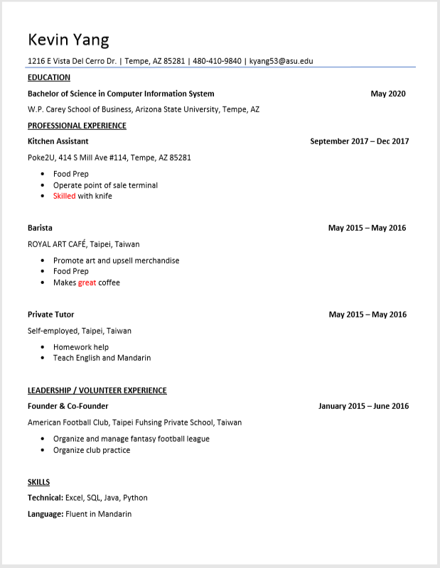

**Team Journal Entries**

|  |  |  |
| --- | --- | --- |
| ***Team Member Name: John Beguhl*** | | |
| ***Date of Work Performed*** | ***Description work performed*** | ***Time Spent on Work Performed (HRS)*** |
| 9/8/2019 | Filled out questionaire for team intros | 0.5 |
| 9/8/2019 | Wrote introduction for Zu | 0.45 |
| 9/10/2019 | Had a team meeting on next steps for Milestone 1 | 0.25 |
| 9/12/2019 | Updated resume | 0.6 |
| 9/12/2019 | uploaded resume to Milestone 1 with headshot | 0.15 |
| 9/12/2019 | Drafted team Charter | 0.85 |
| 9/12/2019 | Edited formating of Milestone 1 and provided feedback on logo | 0.25 |
| 9/12/2019 | Updated histogram | 0.1 |
| 9/12/2019 | Updated Meeting Agneda | 0.15 |
| 9/13/2019 | Created site to find meeting times | 0.2 |
| 9/15/2019 | Updated histogram | 0.1 |
| 9/15/2019 | Proofread Documents and intitialed documents and uploaded journal entry | 0.4 |
| 9/18/2019 | Team Meeting - discussing how to approach Milestone 2 | 0.5 |
| 9/20/2019 | Read business rules for client | 0.5 |
| 9/23/2019 | Team Meeting- Worked on EERD | 1.3 |
| 9/24/2019 | Client EERD | 0.5 |
| 9/25/2019 | TeamMeeting - Finalized the EERD | 0.5 |
| 9/28/2019 | Worked on the Data Dictionary | 0.3 |
| 9/29/2019 | Update journal entries and histogram. Proofread document and Submitted assignment | 1 |
| ***Team Member Name: John Beguhl*** | | |
| 10/2/2019 | Worked on Fixing ERD | 0.3 |
| 10/16/2019 | Generating Data For the database | 2 |
| 10/16/2019 | Updating Data Dictionary | 0.5 |
| 10/19/2019 | Start Writing Script | 0.5 |
| 10/27/2019 | Creating Tables in SQL and formatting and ordering Scripts | 2 |
| 10/31/2019 | Team Meeting: Discussed Next Steps For Mileston 4 | 0.7 |
| 11/2/2019 | Fixing errors in the script | 0.5 |
| 11/4/2019 | Team Meeting: Discussed Next Steps and spread out the work evenly | 1.1 |
| 11/7/2019 | Worked on Test Queries | 1 |
| 11/8/2019 | Finished Quieries took screenshots and trouble shot any erros | 2.5 |
| 11/8/2019 | Updated Journal entries and Histogram and proofread | 0.3 |
| 11/12/2019 | Team Meeting- ideas for Visualization | 0.5 |
| 11/14/2019 | Team Meeting- Talked about indexes | 0.5 |
| 11/21/2019 | Worked on Data Visulization in tableau | 1.5 |
| 11/24/2019 | Team Meeting-Finished IC-10 | 1 |
| 11/24/2019 | Team meeting-Worked on Index(IC-11) | 1 |
| 11/24/2019 | Team Meeting-Worked on Triggers for Mileston 5 | 1 |
| 11/25/2019 | Team Meeting- worked on Procedures and transactions for Milestone | 2.75 |
| 11/26/2019 | Team Meeting-Finished procedure | 0.5 |
| 11/26/2019 | Proofread Documents and intitialed documents and uploaded journal entry | 0.2 |
| 11/29/2019 | Worked on Assignment 5 with Team and IC -12 | 7 |
| ***Team Member Name: John Beguhl*** | | |
| 12/1/2019 | Start working on the powerpoint | 1.5 |
| 12/2/2019 | Finalize the powerpoint | 1 |
| 12/3/2019 | Met up with John to review and run the presentation | 0.5 |
| 12/7/2019 | worked on milestone 7 - client intro/ executive summary and | 5 |
| 12/8/2019 | Updated histogram and proofread document | 0.6 |
|  | Total Hours for John Beguhl | 44.55 |

|  |  |  |
| --- | --- | --- |
| ***Team Member Name: Jisung Woo*** | | |
| ***Date of Work Performed*** | ***Description work performed*** | ***Time Spent on Work Performed (HRS)*** |
| 8/29/2019 | Gathered Team's information | 0.2 |
| 8/29/2019 | Created Milestone 1 Google Drive Folder and Document | 0.1 |
| 9/7/2019 | Answered 15 questions from "100 getting to know you questions" | 1 |
| 9/8/2019 | Wrote Yannan Zhu's introduction | 1 |
| 9/10/2019 | Had a team meeting (arrived late) | 0.17 |
| 9/10/2019 | Created Title Page and researched for suitable logo | 0.5 |
| 9/10/2019 | Created multiple documents, Agenda, Individual Journal Entries, Logo ideas, and resource Histogram | 2 |
| 9/11/2019 | Declared for chair position | 0.02 |
| 9/11/2019 | Edited Meeting Agenda for both 8/29/2019 and 9/10/2019 | 1.5 |
| 9/11/2019 | Updated and uploaded my resume and pictures | 0.75 |
| 9/11/2019 | Edited Team Profile section on Milestone one | 0.25 |
| 9/11/2019 | Updated Resource Histogram | 0.1 |
| 9/12/2019 | Reviewed and Signed Team Agreement | 0.2 |
| 9/13/2019 | Complete "when to meet" website | 0.083 |
| 9/14/2019 | Finalized Meeting Agendas | 0.5 |
| 9/14/2019 | Made sure if all documents were in correct format and correct font | 0.05 |
| 9/14/2019 | Added consequences section on Team Agreement document | 0.17 |
| 9/15/2019 | Finished "Assigned Tasks" section on Milestone 1 | 0.017 |
| 9/15/2019 | Wrote my initials on the pages that I've created and/or worked on | 0.17 |
| 9/15/2019 | Gave team warning on what is still missing from certain people and need in better communication | 0.17 |
| ***Team Member Name: Jisung Woo*** | | |
| 9/18/2019 | Team Meeting | 0.5 |
| 9/18/2019 | Re-create Individual Journal Entries | 0.083 |
| 9/18/2019 | Re-create Unedited Version of Meeting Agenda | 0.083 |
| 9/21/2019 | Milestone 2 Outline on my own | 0.5 |
| 9/23/2019 | Team Meeting | 1.25 |
| 9/23/2019 | Created and edited "Questions for Office Hour/Tutoring Center" | 0.167 |
| 9/24/2019 | Create my own draft of EERD | 0.5 |
| 9/25/2019 | Create a separate document and upload EERD (because I won't be able to attend the meeting) | 0.083 |
| 9/27/2019 | Created data dictionary and worked on it | 0.75 |
| 9/28/2019 | Slightly edited Data Dictionary | 0.167 |
| 9/28/2019 | Fixed minor issues from the team meeting document | 0.0167 |
| 9/28/2019 | Edited on Team16-M2 | 0.167 |
| 9/29/2019 | Updated and uploaded Individual Journal Entries and Resource Histogram | 0.1 |
| 9/29/2019 | Proofread the document | 0.05 |
| 10/16/2019 | Created and worked on Data of Client and children of Employee | 1 |
| 10/22/2019 | Continued and finished working on data | 1.5 |
| 10/22/2019 | Started writing Client and children of Employee Schema | 0.5 |
| 10/24/2019 | Write the scripts | 2 |
| 10/27/2019 | Test all the scripts on MySQL | 0.5 |
| 10/31/2019 | Created and edited milestone 4 folder | 1.67 |
| 10/31/2019 | Fix errors in the scripts | 1 |
| 11/4/2019 | Fix and re-enter the scripts | 1.667 |
| 11/7/2019 | Resolved all problems in the scripts (VISITS, VISITITEMS, BOARDINGINFO) | 2 |
| 11/9/2019 | Test and try to fix the queries | 1 |
| ***Team Member Name: Jisung Woo*** | | |
| 11/10/2019 | Fix queries | 1.833 |
| 11/10/2019 | Combine the queries worked on by other teammate and complete milestone 4 | 0.5 |
| 11/12/2019 | In class team meeting, brainstored IC10 story ideas | 0.5 |
| 11/14/2019 | In class team meeting, discussed solution indexes | 0.5 |
| 11/21/2019 | Team meeting: Met with the team and worked on the views for the visualization | 1 |
| 11/24/2019 | Team meeting: Finished the visualization part of IC10 | 1 |
| 11/24/2019 | Team meeting: Started and finished Indexes | 1 |
| 11/24/2019 | Team meeting: Started and finished Trigger | 1 |
| 11/25/2019 | Team meeting: Started and finished Transaction | 1 |
| 11/25/2019 | Team meeting: Started working on Procedure | 2 |
| 11/26/2019 | Team meeting: Start and Finish Team16-M5.pdf and Team16-M5.txt | 1 |
| 11/26/2019 | Team meeting: Proofread M5 and uploaded journal entry | 0.03 |
| 11/29/2019 | Started and Finished Assignment 5 and IC12 with the team at the Hayden Library | 7 |
| 11/30/2019 | Start drawing out the layout of the powerpoint | 1 |
| 12/1/2019 | Start working on the powerpoint | 1.5 |
| 12/2/2019 | Finalize the powerpoint | 1 |
| 12/3/2019 | Met up with John to review and run the presentation | 0.5 |
| 12/7/2019 | Combined and edited the Meeting Agenda combination section and resume section from M7 | 1 |
| 12/8/2019 | Continue working on Milestone 7, combining scripts, editing and formatting | 2.5 |
| 12/8/2019 | Proofread the document | 0.5 |
|  | Total Hours for Jisung Woo | 52.5667 |

|  |  |  |
| --- | --- | --- |
| ***Team Member Name: Kevin Yang*** | | |
| ***Date of Work Performed*** | ***Description work performed*** | ***Time Spent on Work Performed (HRS)*** |
| 9/6 2019 | Answered team questionaire for member introduction | 1 |
| 9/10 2019 | Team meeting | 0.25 |
| 9/11 2019 | Write introduction for myself | 1 |
| 9/12 2019 | Team logo development (image editing) | 0.2 |
| 9/14 2019 | Update team profile | 0.1 |
| 9/14 2019 | Upload resume to team google doc | 0.2 |
| 9/14 2019 | Upload headshot to team google doc | 0.7 |
| 9/14 2019 | Update histogram | 0.1 |
| 9/14 2019 | Upload group availabilty schedule to team google doc | 0.2 |
| 9/14 2019 | Update assigned tasks on team google doc | 0.3 |
| 9/15 2019 | Create chart for team histogram | 0.5 |
| 9/15 2019 | Put initial on pages worked on | 0.25 |
| 9/15 2019 | Upload Journal Entry to team google doc | 0.1 |
| 9/15 2019 | Check font and formatting on document | 0.1 |
|  | Total Hours(9/6 ~ 9/15): | 5 |
| 9/18 2019 | Team Meeting | 0.25 |
| 9/23 2019 | Team Meeting | 1.1 |
| 9/25 2019 | Office Hour (ERD) | 1 |
| 9/25 2019 | Team Meeting | 0.5 |
| 9/28 2019 | Recreate Team Histogram | 0.167 |
| 9/28 2019 | Update Histogram | 0.167 |
| 9/28 2019 | Data dictionary definiton | 1 |
| 9/29 2019 | Update Histogram | 0.05 |
| 9/29 2019 | Upload Journal Entry to team google doc | 0.05 |
| ***Team Member Name: Kevin Yang*** | | |
|  | Total Hours (9/18 ~ 9/29): | 4.284 |
| 10/2 2019 | Office Hour | 1 |
| 10/22 2019 | Create data for Scalawag | 1.42 |
| 10/26 2019 | Draw Data Schema | 0.09 |
| 10/26 2019 | Write Data script | 2 |
| 10/27 2019 | Upload Data script | 0.017 |
| 10/27 2019 | Draw Data Schema | 1 |
| 10/27 2019 | Data Script Revision | 0.6 |
| 10/27/ 2019 | PDF submission file formatting | 0.083 |
|  | Total Hours (10/2 ~ 10/27): | 6.21 |
| 10/31/2019 | Team Meeting | 0.67 |
| 11/4/2019 | Team Meeting | 1 |
| 11/10 2019 | Advanced query test Create view | 1.23 |
| 11/10 2019 | Basic tests and Fixing Create View | 2.67 |
|  | Total Hours (10/31~11/10): | 5.57 |
|  |  |  |
| 11/14/2019 | Team Meeting: Discuss solution for indexes | 0.5 |
| 11/21/2019 | Team Meeting: Discuss solution for indexes and triggers | 1 |
| 11/24/2019 | Team Meeting: In Class Exercise 10 | 3 |
| 11/25/2019 | Team Meeting: Finish Procedure and Transaction M5 | 3 |
| 11/26/2019 | Team Meeting: Complete and Submit M5 | 1 |
|  | Total Hours (11/14~11/26): | 8.5 |
| 11/29/2019 | Team Meeting: Worked on A5 and IC12 | 7 |
| 12/1/2019 | Started working on power point | 1.5 |
| 12/2/2019 | Finalize power point | 1 |
| 12/8/2019 | Final Deliverables: 16 sample queries | 4.167 |
| 12/8/2019 | Query and upload sample table | 0.5 |
| ***Team Member Name: Kevin Yang*** | | |
| 12/8/2019 | Upload M7 content and proofread | 0.5 |
|  | Total Hours (11/29~12/8): | 14.667 |
|  | Total hours for Kevin Yang | 44.231 |

**Team Histogram**

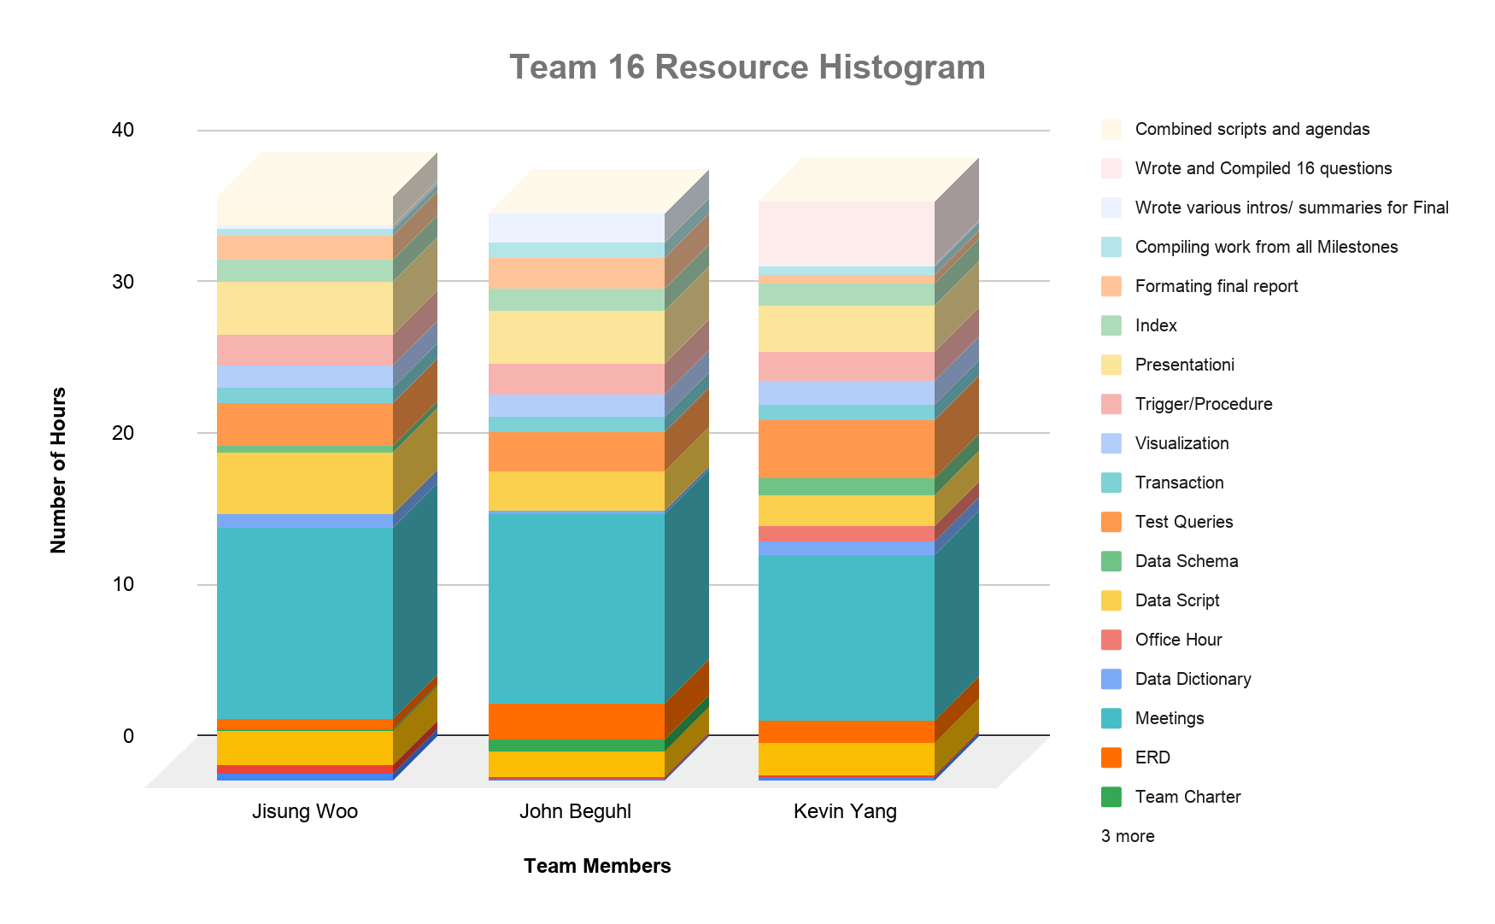

**Appendix C**

**Team Meeting Agendas**

**Date & Time: 8/29/2019 1:30 PM - 2:45 PM**

**Team Meeting for: (Sparky’s Finest #16)**

**Prepared by: (JW)**

**Client’s Name: (TBA)**

**Team members in attendance:**

**1. Jisung Woo 4. Yannan Zhu**

**2. John Beguhl 5. Zuhair Rauf**

**3. Kevin Yang 6.**

**Meeting Objective:** Get the project off to an effective start by introducing all team members, reviewing team goals, and discussing plans.

**Agenda:**

* Introductions of attendees
* Review of project background
* Review of project-related documents (i.e. project charter/code of ethics)
* Discussion of team member roles
* Gather contact information
* Download Group me
* List of action items from meeting

|  |  |  |
| --- | --- | --- |
| **Action Item** | **Assigned To** | **Due Date** |
| Team assigned and meeting | Everyone | 8/29/2019 |
| Do Introduction | Everyone | 9/8/2019 |
| Finalize the team name | Everyone | 9/8/2019 |
| Project Background Idea discussion (over text) | Everyone | 9/8/2019 |

**Time meeting ended: 2:47 PM**

**Date and time of next meeting: 9/10/2019**

**Date & Time: 9/10/2019 1:30 PM - 2:45 PM**

**Team Meeting for: (Sparky’s Finest #16)**

**Prepared by: (JW)**

**Client’s Name: (TBA)**

**Team members in attendance:**

**1. (Chair) - Jisung Woo 4. Zuhair Rauf**

**2. John Beguhl 5.**

**3. Kevin Yang 6.**

**Team members absent:**

1. **Yannan Zhu**

**Meeting Objective:** Have a brief discussion on what the team should improve and finish on Milestone 1.

**Agenda:**

* Discuss whether we should meet in person or use calling/texting app to have our next meeting
* Review progress and discuss on what to improve
* Set date to when to finish the works that is in progress
* Assigned someone to work on Team Membership Agreement

|  |  |  |
| --- | --- | --- |
| **Action Item** | **Assigned To** | **Due Date** |
| Team Meeting | Everyone | 9/10/2019 |
| Create other documents | Jisung | 9/10/2019 |
| Title Page | Jisung | 9/10/2019 |
| Find Title Page logo | Jisung | 9/10/2019 |
| Work on Meeting Agenda | Jisung | 9/12/2019 |
| Upload Professional Photo | Everyone | 9/11/2019 |
| Work on Resume section | Everyone | 9/11/2019 |
| Work on Resource Histogram | Everyone | 9/11/2019 |
| Work on Individual Journal Entries | Everyone | 9/15/2019 |
| Team Membership Agreement | John | 9/12/2019 |
| Sign Team Membership Agreement | Everyone | 9/12/2019 |
| Sign When2meet.com | Everyone | 9/13/2019 |
| Finalize both Meeting Agenda | Jisung | 9/14/2019 |
| Double check the rubric to see if we met every requirements | Jisung | 9/15/2019 |
| Finalize editing | Everyone | 9/15/2019 |
| Write initials on the pages created/worked on | Everyone | 9/15/2019 |
| Submit Milestone 1 | John Beguhl | 9/16/2019 |

**Time meeting ended: 1:30 PM**

**Date and time of next meeting: After Milestone 1 due date**

Jw jb

**Date & Time: 9/10/2019 1:30 PM - 2:45 PM**

**Team Meeting for: (Sparky’s Finest #16)**

**Prepared by: (JW)**

**Client’s Name: (Scalawa)**

**Team members in attendance:**

**1. (Chair) - Jisung Woo 4. Zuhair Rauf**

**2. John Beguhl 5.**

**3. Kevin Yang 6.**

**Team members absent:**

1. **Yannan Zhu**

**Meeting Objective:** Have a brief discussion on what the team should improve and finish on Milestone 1.

**Agenda:**

* Discuss whether we should meet in person or use calling/texting app to have our next meeting
* Review progress and discuss on what to improve
* Set date to when to finish the works that is in progress
* Assigned someone to work on Team Membership Agreement

|  |  |  |
| --- | --- | --- |
| **Action Item** | **Assigned To** | **Due Date** |
| Team Meeting | Everyone | 9/10/2019 |
| Create other documents | Jisung | 9/10/2019 |
| Title Page | Jisung | 9/10/2019 |
| Find Title Page logo | Jisung | 9/10/2019 |
| Work on Meeting Agenda | Jisung | 9/12/2019 |
| Upload Professional Photo | Everyone | 9/11/2019 |
| Work on Resume section | Everyone | 9/11/2019 |
| Work on Resource Histogram | Everyone | 9/11/2019 |
| Work on Individual Journal Entries | Everyone | 9/15/2019 |
| Team Membership Agreement | John | 9/12/2019 |
| Sign Team Membership Agreement | Everyone | 9/12/2019 |
| Sign When2meet.com | Everyone | 9/13/2019 |
| Finalize both Meeting Agenda | Jisung | 9/14/2019 |
| Double check the rubric to see if we met every requirements | Jisung | 9/15/2019 |
| Finalize editing | Everyone | 9/15/2019 |
| Write initials on the pages created/worked on | Everyone | 9/15/2019 |
| Submit Milestone 1 | John Beguhl | 9/16/2019 |

**Time meeting ended: 1:30 PM**

**Date and time of next meeting: After Milestone 1 due date**

Jw jb

**Date & Time: 9/18/2019 2pm**

**Team Meeting for: (Sparky’s Finest #16)**

**Prepared by: (JB)**

**Client’s Name: Scalawags Vet Clinic**

**Team members in attendance:**

**1. (Chair) - John Beguhl 4.Derrik Zhu**

**2. Zuhair Rauf 5. Kevin yang(late)**

**3. Jisung Woo 6.**

**Meeting Objective:**  Figure out what we need to do for Milestone 2. Decide on our next steps.

**Agenda:**

* Discuss next steps
* What is the best way of finishing ERD
* Figure out next meeting time

|  |  |  |
| --- | --- | --- |
| **Action Item** | **Assigned To** | **Due Date** |
| Finish Assignment 1(individual) | Everyone | 9/20/2019 |
| Mark Up Business Rules | Everyone | 9/23/2019 |
| Call noble library | Jisung | 9/20/2019 |
| Ask Dr. Moser about journal entry | Zu | 9/19/2019 |

**Time meeting ended: 2:33 PM**

**Date and time of next meeting: Monday September 23rd 4:30pm**

**Date & Time: 9/23/2019 4:30 pm**

**Team Meeting for: (Sparky’s Finest #16)**

**Prepared by: (JB)**

**Client’s Name: Scalawags Vet Clinic**

**Team members in attendance:**

**1. (Chair) - Zuhair Rauf 4.Derrik Zhu**

**2. John Beguhl 5. Kevin yang(late)**

**3. Jisung Woo 6.**

**Meeting Objective:**  Figure out the EERD for Milestone 2 and plan the data dictionaries.

**Agenda:**

* Discuss next steps
* What is the best way of finishing ERD
* Figure out next meeting time

|  |  |  |
| --- | --- | --- |
| **Action Item** | **Assigned To** | **Due Date** |
| Go to Professor’s office hours Wed 12-1 pm | Kevin, Derrik | 9/20/2019 |
| Everyone complete person version of EERD | Everyone | 9/24/2019 |
| Create data dictionary skeleton | Jisung | 9/25/2019 |

**Time meeting ended: 5:45 pm**

**Date and time of next meeting: Wednesday September 25rd 2:00 pm**

**Date & Time: 9/25/2019 2pm**

**Team Meeting for: (Sparky’s Finest #16)**

**Prepared by: (JB)**

**Client’s Name: (Scalawags Veterinary Clinic)**

**Team members in attendance:**

**1. Zuhair Rauf 4.Chair- Yannan Zhu**

**2. John Beguhl 5.**

**3. Kevin Yang 6.**

**Team members absent:**

1. **Jisung Woo**

**Meeting Objective:** Complete ERD and plan to do Data Dictionary.

**Agenda:**

* After going to office hours, the first draft is corrected according to the professor's suggestions.
* Complete ERD

|  |  |  |
| --- | --- | --- |
| **Action Item** | **Assigned To** | **Due Date** |
| Complete ERD | Everyone | 9/25/2019 |
| Data Dictionary | Everyone | 9/27/2019 |
|  |  |  |
|  |  |  |

**Time meeting ended: 2:30**

**Date and time of next meeting: TBA**

**Date & Time: 10/10/2019**

**Team Meeting for: Team 16: Sparky’s Finest**

**Client’s Name: Veterinary Clinic**

**Team members in attendance:**

**1. Jisung Woo 2. John Beguhl**

**3. Yannan Zhu 4. Kevin Yang**

**5. Zuhair Rauf**

**Meeting Objective:** Discuss and plan metadata specifications for all project database tables.

**Agenda:**

* Create database schema
* Identify order of entry of tables
* Draft metadata code for each database table
* Assign coding of metadata; list of action items from meeting

|  |  |  |
| --- | --- | --- |
| **Action Item** | **Assigned To** | **Due Date** |
| Update milestone 3 folder | John Beguhl | 10/17/2019 |
| Create Schema | Zuhair Rauf | 10/17/2019 |
| Assist Creating schema | Jisung Woo | 10/17/2019 |
| Write Color/Owners | Kevin Yang | 10/17/2019 |
| Write Employees/Full-Time | Yannan Zhu | 10/17/2019 |

**Time meeting ended: *2:45 PM***

**Date and time of next meeting: *10/17/2019 4:30 PM***

**Date & Time: 10/17/2019**

**Team Meeting for: Team 16: Sparky’s Finest**

**Client’s Name: Veterinary Clinic**

**Team members in attendance:**

**1. Jisung Woo - Chair 2. John Beguhl**

**3. Yannan Zhu 4. Kevin Yang**

**Team members absent:**

1. **Zuhair Rauf**

**Meeting Objective:** Discuss and plan metadata specifications for all project database tables.

**Agenda:**

* Check each data for its accuracy
* Questions and concerns about the data
* Writing SQL?
* Start on Schema

|  |  |  |
| --- | --- | --- |
| **Action Item** | **Assigned To** | **Due Date** |
| Complete the data | Everyone | 10/20/2019 |
| Write data script (Employee) | John | 10/20/2019 |
| Write data script (Client) | Jisung | 10/20/2019 |
| Do your data schema (Paper or gliffy) | Everyone | 10/22/2019 |
|  |  |  |

**Time meeting ended: *4:45 PM***

**Date and time of next meeting: *10/22/2019 2:45 PM***

**Date & Time: 10/31/2019**

**Team Meeting for: Team 16: Sparky’s Finest**

**Client’s Name: Veterinary Clinic**

**Team members in attendance:**

**1. Jisung Woo (Head) 2. John Beguhl**

**3. Yannan Zhu 4. Kevin Yang**

**Team members absent:**

**1. Zuhair Rauf**

**Meeting Objective:** Discuss and plan metadata specifications for all project database tables.

**Agenda:**

* Input the Scripts in the database
* Fix the errors in the scripts
* Continue working on schema

|  |  |  |
| --- | --- | --- |
| **Action Item** | **Assigned To** | **Due Date** |
| Fix Visit | Yannan Zhu | 11/2/2019 |
| Fix Part-Time | John Beguhl | 11/2/2019 |
| Finish Schema | Kevin Yang | 11/2/2019 |
|  |  |  |
|  |  |  |

**Time meeting ended: *2:45 PM***

**Date and time of next meeting: *11/4/2019 TIME TBA***

**Date & Time: 11/4/2019**

**Team Meeting for: Team 16: Sparky’s Finest**

**Client’s Name: Veterinary Clinic**

**Team members in attendance:**

**1. Jisung Woo (Head) 2. John Beguhl**

**3. Kevin Yang**

**Team members Absent:**

**1. Yannan Zhu**

**Meeting Objective:** Discuss and plan metadata specifications for all project database tables.

**Agenda:**

* Fix the errors in the scripts
* Delete and re-enter the fixed scripts

|  |  |  |
| --- | --- | --- |
| **Action Item** | **Assigned To** | **Due Date** |
| FIX VISIT | Yannan | 11/4/2019 |
| Enter fixed scripts into the database | Jisung | 11/5/2019 |
| Write the query | Kevin & John | 11/5/2019 |
|  |  |  |
|  |  |  |

**Time meeting ended: *5:40 PM***

**Date and time of next meeting: *11/7/2019 4:30 PM***

**Date & Time: 11/12/2019**

**Team Meeting for: Team 16: Sparky’s Finest**

**Client’s Name: Veterinary Clinic**

**Team members in attendance:**

**1. Jisung Woo (Head) 2. John Beguhl**

**Team members Absent:**

**1. Kevin Yang**

**Meeting Objective:** Discuss and plan metadata specifications for all project database tables.

**Agenda:**

* Brainstorm IC10 Story ideas

|  |  |  |
| --- | --- | --- |
| **Action Item** | **Assigned To** | **Due Date** |
| Master Visualization (Tableau) | Everyone | 11/14/2019 |

**Time meeting ended: *2:45 PM***

**Date and time of next meeting: *11/14/2019 4:30 PM***

**Date & Time: 11/14/2019**

**Team Meeting for: Team 16: Sparky’s Finest**

**Client’s Name: Veterinary Clinic**

**Team members in attendance:**

**1. Jisung Woo (Head) 2. John Beguhl**

**3. Kevin Yang**

**Meeting Objective:** Discuss and plan metadata specifications for all project database tables.

**Agenda:**

* Discussing indexes, see if everyone understood indexes

|  |  |  |
| --- | --- | --- |
| **Action Item** | **Assigned To** | **Due Date** |
| Go over indexes and understand | Everyone | 11/19/2019 |

**Time meeting ended: *2:45 PM***

**Date and time of next meeting: *11/21/2019 4:30 PM***

**Date & Time: 11/21/2019 & 4:30 PM**

**Team Meeting for: Team 16: Sparky’s Finest**

**Client’s Name: Veterinary Clinic**

**Team members in attendance:**

**1. Jisung Woo (Head) 2. John Beguhl**

**3. Kevin Yang**

**Meeting Objective:** Discuss and plan metadata specifications for all project database tables.

**Agenda:**

* Fix the scripts for Visualization Views
* Start on Indexes

|  |  |  |
| --- | --- | --- |
| **Action Item** | **Assigned To** | **Due Date** |
| Master Indexes and Triggers | Everyone | 11/23/2019 |

**Time meeting ended: *5:30 PM***

**Date and time of next meeting: *11/24/2019 3:00 PM***

**Date & Time: 11/25/2019 & 3:00 PM**

**Team Meeting for: Team 16: Sparky’s Finest**

**Client’s Name: Veterinary Clinic**

**Team members in attendance:**

**1. Jisung Woo (Chair) 2. John Beguhl**

**3. Kevin Yang**

**Meeting Objective:** Discuss and plan metadata specifications for all project database tables.

**Agenda:**

* Finish working on Procedure
* Start and finish transaction

|  |  |  |
| --- | --- | --- |
| **Action Item** | **Assigned To** | **Due Date** |
| Finish Procedure and Transaction from Milestone 5 | Everyone | 11/24/2019 |

**Time meeting ended: 6:00pm**

**Date and time of next meeting: *11/26/2019 4:30pm***

**Date & Time: 11/26/2019 & 4:30 PM**

**Team Meeting for: Team 16: Sparky’s Finest**

**Client’s Name: Veterinary Clinic**

**Team members in attendance:**

**1. Jisung Woo (Chair) 2. John Beguhl**

**3. Kevin Yang**

**Meeting Objective:** Discuss and plan metadata specifications for all project database tables.

**Agenda: (CHANGE AS NECESSARY!)**

* Finish working on Procedure
* Finalize M5
* Submit M5 and in class exercise

|  |  |  |
| --- | --- | --- |
| **Action Item** | **Assigned To** | **Due Date** |
| Finish Procedure | Everyone | 11/26/2019 |
| Edit and finalize Team16-M5.pdf | Jisung | 11/26/2019 |
| Edit and finalize Team16-M5.txt | John | 11/26/2019 |
| Submit M5, IC10 & IC11 | Kevin | 11/26/2019 |

**Time meeting ended: 5:45pm**

**Date and time of next meeting: *11/29/2019 TBA***

**Date & Time: 11/29/2019 & 10 AM**

**Team Meeting for: Team 16: Sparky’s Finest**

**Client’s Name: Veterinary Clinic**

**Team members in attendance:**

**1. Jisung Woo (Chair) 2. John Beguhl**

**3. Kevin Yang**

**Meeting Objective:** Discuss and plan metadata specifications for all project database tables.

**Agenda:**

* Start and Finalize Assignment 5
* Start and Finalize IC-12
* Submit Assignment 5

|  |  |  |
| --- | --- | --- |
| **Action Item** | **Assigned To** | **Due Date** |
| Start and finalize Assignment 5 and IC12 | Everyone | 11/29/2019 |
| Edit IC12 | John | 11/29/2019 |
| Proofread Assignment 5 | Jisung | 11/29/2019 |
| Submit Assignment 5 and IC12 | Kevin or John | 11/29/2019 |

**Time meeting ended: 5:00pm**

**Date and time of next meeting: *11/30/2019 4:30 PM***

**Date & Time: 11/30/2019 & 4:30 PM**

**Team Meeting for: Team 16: Sparky’s Finest**

**Client’s Name: Veterinary Clinic**

**Team members in attendance:**

**1. Jisung Woo (Chair) 2. John Beguhl**

**3. Kevin Yang**

**Meeting Objective:** Discuss and plan metadata specifications for all project database tables.

**Agenda:**

* Discuss and draw out the layout of our powerpoint

|  |  |  |
| --- | --- | --- |
| **Action Item** | **Assigned To** | **Due Date** |
| Attend the next meeting to work on the powerpoint | Everyone | 12/1/2019 |

**Time meeting ended: 5:30pm**

**Date and time of next meeting: *12/1/2019 3:00 PM***

**Date & Time: 12/1/2019 3:00 PM**

**Team Meeting for: Team 16: Sparky’s Finest**

**Client’s Name: Veterinary Clinic**

**Team members in attendance:**

**1. Jisung Woo (Chair) 2. John Beguhl**

**3. Kevin Yang**

**Meeting Objective:** Discuss and plan metadata specifications for all project database tables.

**Agenda:**

* Start and Finish majority of the the presentation

|  |  |  |
| --- | --- | --- |
| **Action Item** | **Assigned To** | **Due Date** |
| Start and finish majority of the presentation | Everyone | 12/1/2019 |

**Time meeting ended: 5:30 PM**

**Date and time of next meeting: *12/2/2019 4:30 PM***

**Date & Time: 12/2/2019 4:30 PM**

**Team Meeting for: Team 16: Sparky’s Finest**

**Client’s Name: Veterinary Clinic**

**Team members in attendance:**

**1. Jisung Woo (Chair) 2. John Beguhl**

**3. Kevin Yang**

**Meeting Objective:** Discuss and plan metadata specifications for all project database tables.

**Agenda:**

* Finish making the presentation and practice presenting

|  |  |  |
| --- | --- | --- |
| **Action Item** | **Assigned To** | **Due Date** |
| Finalize the presentation | Everyone | 12/2/2019 |

**Time meeting ended: 5:30 PM**

**Date and time of next meeting: *TBA***

**Appendix D**

**Presentation Slides**



